A CNN -BASED STRUCTURE FOR CORRELATION OF CONTACTLESS TO CONTACT-BASED FINGERPRINTS

# A PROJECT REPORT

***Submitted by***

# CHENNAREDDY SUSHMITHA REDDY [REGISTER NO:211419104047] MARELLA MANSI [REGISTER NO: 211419104163] PRIYADHARSINI.P [REGISTER NO: 211419104203]

***in partial fulfillment for the award of the degree of***

**BACHELOR OF ENGINEERING**

**IN**

# COMPUTER SCIENCE AND ENGINEERING



**PANIMALAR ENGINEERING COLLEGE, CHENNAI-600123.**

**ANNA UNIVERSITY : CHENNAI 600 025**

# APRIL 2023

PANIMALAR ENGINEERING COLLEGE

## (An Autonomous Institution, Affiliated to Anna University, Chennai)

**BONAFIDE CERTIFICATE**

Certified that this project report **“A CNN-BASED STRUCTURE FOR CORRELATION OF CONTACTLESS TO CONTACT-BASED**

## FINGERPRINTS ” is the bonafide work of “CHENNAREDDY SUSHMITHA REDDY [REGISTER NO: 211419104047], MARELLA MANSI [REGISTER NO: 211419104163] and PRIYADHARSINI.P [REGISTER NO:

**211419104203]”** who carried out the project work under my supervision.

## SIGNATURE Dr.L.JABASHEELA,M.E.,Ph.D., HEAD OF THE DEPARTMENT,

DEPARTMENT OF CSE, PANIMALAR ENGINEERING COLLEGE, NAZARATHPETTAI, POONAMALLEE,

CHENNAI-600 123.

## SIGNATURE Dr.A.HEMLATHADHEVI, M.E., Ph.D., ASSOCIATE PROFESSOR,

DEPARTMENT OF CSE, PANIMALAR ENGINEERING COLLEGE, NAZARATHPETTAI,

POONAMALLEE, CHENNAI-600 123.

Certified that the above candidate(s) was/ were examined in the End Semester Project Viva-Voce Examination held on...........................

# INTERNAL EXAMINER EXTERNAL EXAMINER

**DECLARATION BY THE STUDENT**

## We CHENNAREDDY SUSHMITHA REDDY [REGISTER NO: 211419104047], MARELLA MANSI [REGISTER NO: 211419104163] and

**PRIYADHARSINI.P [REGISTER NO: 211419104203]** hereby declare that this project report titled “**A CNN-BASED STRUCTURE FOR CORRELATION OF CONTACTLESS TO CONTACT-BASED FINGERPRINTS ”**, under the guidance of **Dr. A. HEMLATHADHEVI, M.E., Ph.D., ASSOCIATE**

**PROFESSOR** , is the original work done by us and we have not plagiarized or submitted to any other degree in any university by us.

# CHENNAREDDY SUSHMITHA REDDY

**MARELLA MANSI PRIYADHARSINI.P**

**ACKNOWLEDGEMENT**

We would like to express our deep gratitude to our respected Secretary and Correspondent **Dr.P.CHINNADURAI, M.A., Ph.D.,** for his kind words and enthusiastic motivation, which inspired us a lot in completing this project.

We express our sincere thanks to our beloved Directors **Tmt.C.VIJAYARAJESWARI**, **Dr.C.SAKTHI KUMAR,M.E.,Ph.D.,** and **Dr.SARANYASREE SAKTHI KUMAR B.E.,M.B.A.,Ph.D.,** for providing us

with the necessary facilities to undertake this project.

We also express our gratitude to our Principal **Dr.K.Mani, M.E., Ph.D.,** who facilitated us in completing the project.

We thank the Head of the CSE Department, **Dr. L.JABASHEELA , M.E.,Ph.D.,**

for the support extended throughout the project.

We would like to thank my **Project Guide Dr. A. HEMLATHADHEVI, M.E., Ph.D., ASSOCIATE PROFESSOR** and all the faculty members of the Department of CSE for their advice and encouragement for the successful completion of the project.

**CHENNAREDDY SUSHMITHA REDDY**

**MARELLA MANSI PRIYADHARSINI.P**

**ABSTRACT**

The necessity for personal data protection has become increasingly important in recent years. The fingerprint is the most commonly used biometrics to verify a user’s identity for it being both unique and permanent throughout an individual's life. Fingerprint biometrics are extensively used by the forensic department in criminal investigations and by governmental and private institutions for various sorts of personal (human) identification and verification.Accurately comparison of contactless fingerprint images with contact-based fingerprints is critical for the success of emerging contactless fingerprint technologies.This offers more hygienic and deformation-free acquisition of fingerprint features.This project aims to create a minutiae extraction fingerprint model based on Convolution Neural Networks (CNN) as a quick and alternative method to fingerprint identification systems for Bank Transaction Process.Our approach introduces pre-processing methods to capture regions of interest in fingerprint images to allow effective feature extraction. This determines the best CNN architecture that yields excellent recognition performance, which is rapid and accurate in classification.

**TABLE OF CONTENTS**

**CHAPTER NO TITLE PAGE NO**

|  |  |
| --- | --- |
| **ABSTRACT** | ⅴ |
| **LIST OF TABLES** | ⅷ |
| **LIST OF FIGURES** | ⅸ |
| **LIST OF SYMBOLS,ABBREVIATIONS** | ⅹ |
| **1. INTRODUCTION** |  |
| 1.1 Overview | 1 |
| 1.2 Problem Definition | 3 |
| **2. LITERATURE SURVEY** | 4 |
| **3. SYSTEM ANALYSIS** |  |
| 3.1 Existing System | 20 |
| 3.2 Proposed System | 21 |
| 3.3 Feasibility Study | 22 |
| 3.4 Hardware Environment | 22 |
| 3.5 Software Environment | 22 |
| **4. SYSTEM DESIGN** |  |
| 4.1 ER Diagram | 25 |
| 4.2 Data Dictionary | 26 |
| 4.3 Data Flow Diagram | 27 |
| 4.4 UML Diagrams | 29 |

1. **SYSTEM ARCHITECTURE**
   1. System Architecture 33
   2. Module Design Specification 35
   3. Algorithms 39
2. SYSTEM IMPLEMENTATION
   1. Client-side Coding 49
   2. Server-side Coding 67
3. SYSTEM TESTING/PERFORMANCE ANALYSIS
   1. Test Cases & Reports 76
   2. Performance Analysis 77
4. CONCLUSION
   1. Conclusion 80
   2. Future Enhancements 81

APPENDICES

* 1. Sample Screens 82
  2. Plagiarism Report

REFERENCES 85

# LIST OF TABLES

**TABLE NO. TABLE DESCRIPTION PAGE NO.**

4.1

7.1

Data Dictionary 26

Test Cases & Reports 76

**LIST OF FIGURES**

|  |  |  |
| --- | --- | --- |
| **FIG NO.** | **FIGURE DESCRIPTION** | **PAGE NO.** |
| 4.1 | ER Diagram | 25 |
| 4.2 | DFD Level 0 | 27 |
| 4.3 | DFD Level 1 | 28 |
| 4.4 | DFD Level 2 | 28 |
| 4.5 | Use Case Diagram | 29 |
| 4.6 | Class Diagram | 30 |
| 4.7 | Activity Diagram | 31 |
| 4.8 | Sequence Diagram | 32 |
| 5.1 | Architecture Diagram | 34 |
| 5.2 | 3x3 neighbourhood | 37 |
| 5.3 | Properties of Crossing Numbers | 37 |
| 5.4 | An Artificial Neural Network | 42 |
| 5.5 | Architecture of CNN | 43 |
| 5.6 | Representation of Convolutional Process | 44 |
| 5.7 | Representation of Max Pooling and Average Pooling | 45 |
| 5.8 | ReLU Transfer Function | 46 |
| 5.9 | Representation of ReLU Functionality | 46 |

|  |  |  |
| --- | --- | --- |
| 5.10 | Softmax Transfer Function | 47 |
| 7.1 | Confusion Matrix | 78 |
| A.1 | Home Page | 82 |
| A.2 | Create Card Page | 82 |
| A.3 | Fingerprint Authentication Page | 83 |
| A.4 | Transaction Page | 83 |
| A.5 | Transaction Successful | 84 |
| A.6 | Transaction Failure | 84 |

**LIST OF SYMBOLS**

**S.NO NOTATION**

**NAME**

**NOTATION DESCRIPTION**

1. 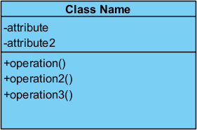Class Represents a

collection of similar entities grouped together.

1. Association Associations

represents a static 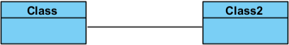 relationships between

the classes.

1. Actor It aggregates several

classes into a single class.

1. 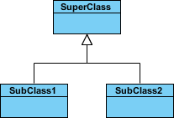Generalization It is displayed as a solid line with a hollow arrowhead that points from the child element to the parent element.
2. Include It is depicted

as using the

functionality of another use case, the relationship between the use cases is named as include or uses relationship.

1. Communication

Communication between various use cases.

1. State State of the process.
2. Initial State Initial state of the

 object.

1. Final state Final state of the

object.

1. Control flow Represents various

control flow between the states.

1. 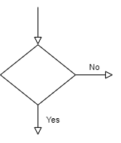Decision box Represents decisions

making process from a constraint.

1. 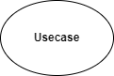Use case Interaction between

the system and external environment.

1. Data

Process/State

A circle in DFD represents a state or process which has been triggered due to some event or action.

1. External Entity Represents external entities such as keyboard, sensors, etc.,
2. Transition Represents

communication that occurs between processes.

1. 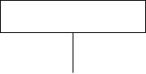Object Lifeline Representation of the vertical dimensions of the objects

communication.

1. Message  Represents the

message exchanged.

# LIST OF ABBREVIATIONS

**ABBREVIATION EXPANSION**

UML GPU CNN ER GAN C2CL ReLU PIN

Unified Modeling Language Graphics Processing Unit Convolutional Neural Network Entity-Relationship

Generative Adversarial Network

Contact to Contactless Fingerprint Matching Rectified Linear Unit

Personal Identification Number

# CHAPTER 1 INTRODUCTION

* 1. **OVERVIEW**

Fingerprint matching is a common biometric modality which can be used almost anywhere for quick and easy security, from consumer products, like phones, to government facilities. The reason the use of fingerprints is so widespread is because of their fast-matching capabilities by matching only particular feature points on a fingerprint called minutiae points. These minutiae points are extracted from the ridges and valleys on a fingerprint. Most fingerprint matching systems use these minutiae points for matching. While the entire fingerprint is generally unique individual minutiae points might match up to other people minutiae points so creating a matching vector of minutiae points that has enough data points is directly correlated to higher security, so any fingerprint matching software wants to have the maximum number of minutiae points it can have.There are a multitude of ways to collect fingerprints; these methods include using ink and paper to get a rolled fingerprint, using a contact-based capacitive or optical fingerprint reader, and capturing a close-up picture of a finger, which is referred to as a finger-photo. Any contact-based fingerprint can suffer from elastic deformation, which is when the skin compresses or stretches while applying pressure onto paper or a platen. While contactless finger-photo collection lacks elastic deformation due to the inherent structure of the capturing process . However, contactless data suffer from a different kind of distortion, perspective distortion caused by the 3D shape of the fingertips. With a rolled fingerprint, one can get an even view of all points on a finger from edge to edge. However, from a finger-photo, the edges of the finger are curved compared to the center of the finger. This compresses the minutiae points and makes them harder to identify and represent accurately in a fingerprint template. Contactless however also has the added benefits of being hygienic and in

today’s age of Covid-19 this is much more valuable. Cameras are ubiquitous in modern society and having the ability to create an equivalent fingerprint without any deformations from a finger-photo allows even more accessibility to biometric security.The main objective of this paper is to create a method that can take a finger-photo and turn it into a fingerprint by removing the perspective distortion. First and foremost is to create synthetic fingerprints from contactless based finger-photos however a good model will be able to accomplish both the primary and secondary objectives at the same time.

# PROBLEM DEFINITION:

This project aims to design a convolutional neural network (CNN) to classify individual fingerprints unique for biometric identification for a bank transaction process.For fingerprint matching, the majority of fingerprint recognition systems extract the ridge map and minutiae features. Our research aims to create a Convolutional Neural Network (CNN) that can accurately identify fingerprints images of an individual. CNN architecture includes a Max Pooling, Rectified Linear Unit(ReLU), and a Fully Connected layer. The first part of the project aims to create the best model architecture and improve the model accuracy.The current research attempts to use minutiae extraction to identify fingerprint images for each class,resulting in increased classification accuracy. From the sample provided, the CNN learns distinct characteristics for each class. The proposed system classifies the fingerprint images dataset to the respective identifier (person).

# CHAPTER 2 LITERATURE SURVEY

* 1. **LITERATURE SURVEY**

## A CNN-based Framework for Comparison of Contactless to Contact-based Fingerprints [1] in IEEE Access

**Author: Chenhao Lin, Ajay Kumar Year:2022**

Accurate comparison of contactless 2D fingerprint images with contact-based fingerprints is critical for the success of emerging contactless 2D fingerprint technologies, which offer more hygienic and deformation-free acquisition of fingerprint features. Convolutional neural networks (CNN) have shown remarkable capabilities in biometrics recognition. However, there has been almost nil attempt to match fingerprint images using CNN-based approaches. This paper develops a CNN-based framework to accurately match contactless and contact-based fingerprint images. Our framework firstly trains a multi-Siamese CNN using fingerprint minutiae, respective ridge map and specific region of ridge map. This network is used to generate deep fingerprint representation using a distance-aware loss function.

## Methodology used:

To correctly compare contactless and contact-based fingerprint images, use a CNN-based framework.

## Pros:

To guarantee the robustness of learning minutiae feature correspondences, it incorporates the most trustworthy minutiae features along with the corresponding ridge flow maps.

## Cons:

.The falsely rejected real fingerprints and falsely accepted fake fingerprints show the limitations in the suggested method's matching accuracy.

## Towards More Accurate Matching of Contactless Fingerprints With a Deep Geometric Graph Convolutional Network ,[2] in IEEE Transactions on Biometrics,Behaviour,and Identity Science

**Author:Yelin Shi, Zhao, Shuxin Liu and Manhua Liu Year:2023**

The success of new contactless 2D fingerprint technologies, which offer more hygienic and deformation-free acquisition of fingerprint features, depends on accurate comparison of contactless 2D fingerprint images with contact-based fingerprints. Convolutional neural networks (CNN) have demonstrated impressive skills in the recognition of biometrics. However, using CNN-based methods to compare fingerprint images has hardly ever been attempted. In order to correctly compare contactless and contact-based fingerprint images, this paper creates a CNN-based framework. Utilizing fingerprint minutiae, the appropriate ridge map, and a specific area of the ridge map, our framework first trains a multi-Siamese CNN. Using a distance-aware loss function, this network generates deep DNA representations.

## Methodology used:

It suggested a fingerprint matching method that computed minutiae correspondences by combining minutiae coordinates, orientation, and quality information

## Pros:

It suggests a deep geometric graph neural network to collectively learn the multi-level minute features and their similarities in an end-to-end manner, leading to more precise matching of contactless fingerprints

## Cons:

Due to perspective distortions, differences in lighting, and postures, accurate contactless fingerprint matching is still difficult.

## C2CL: Contact to Contactless Fingerprint Matching ,[3] in IEEE Transactions on Information Forensics and Security

**Author:Steven A. Grosz ,Joshua J. Engelsma ,Eryun Liu and Anil K. Jain Year:2022**

It shows an end-to-end automated system, dubbed C2CL, made up of a mobile finger photo capture app, preprocessing, and matching algorithms, to address the problems preventing earlier cross-matching methods. These problems include the low ridge-valley contrast of contactless fingerprints, the variability of the finger's roll, pitch, yaw, and distance from the camera, the non-linear distortion of contact-based fingerprints, and the different image qualities of smartphone cameras. Contactless fingerprints are prepared by our preparation algorithm, which segments, improves, scales, and unwinds them. Our matching algorithm then gets texture models. We used a sequestered dataset of 9,888 contactless 2D fingerprints and matching contact-based fingerprints from 206 people to evaluate the cross-database performance of our proposed algorithm. (For each topic, use two thumbs and two index fingers).

## Methodology used:

To address the issues preventing cross-matching methods, it provides an end-to-end automated system, dubbed C2CL, made up of a mobile finger photo capture app, preprocessing, and matching algorithms.

## Pros:

A much more accurate indicator of how C2CL would function in the real world is the cross-database evaluation.

## Cons:

There are many variables that complicate the cross-matching performance and cause both false rejects and false accepts errors, despite the low error rates that are obtained across each dataset.

## Methods and Applications of Fingertip Subcutaneous Biometrics Based on Optical Coherence Tomography [4]

**Author:Yang Yu, Haixia Wang, Yilong Zhang, Ronghua Liang and Peng Chen Year:2023**

With the effective use of optical coherence tomography (OCT), subcutaneous biometrics from the fingertip, including internal fingerprints and sweat ducts, have been gathered. To the best of our understanding, despite the fact that researchers have focused on various subcutaneous biometrics topics, there hasn't been much analysis of the techniques and applications.In this paper, every significant stage in the processing of subcutaneous biometrics—including the design of the OCT system, the extraction of subcutaneous biometrics, and the identification and anti-counterfeiting applications of new features—is surveyed.Subcutaneous fingertip biometrics will surely emerge as a new development in extremely secure authentication.

This article aims to assist researchers working on fingertip subcutaneous biometrics by offering organized references and insights into approaches and applications.

## Methodology used:

It offers a review of the entire fingertip subcutaneous biometrics procedure from collection to application in detail.

## Pros:

Instead of the conventional external fingerprints and skin sweat pores, fingerprint biometric features based on OCT, primarily internal fingerprints and sweat glands, have superior identification and anti-counterfeiting performance.

## Cons:

The system's performance equilibrium, including its sensitivity, resolving power, and depth of detection, needs to be improved.OCT's internal DNA extraction process has some drawbacks as well.

## Contactless Fingerprint Recognition Using Deep Learning—A Systematic Review ,[5] in MDPI

**Author:A M Mahmud Chowdhury and Masudul Haider Imtiaz Year:2022**

The accuracy of the deep-learning-based methods was said to be better than that of the competition. The purpose of this study was to give a systematic review of these accomplishments and the acknowledged limitations. In order to conduct this review, three techniques were investigated: (i) the contactless fingerprint recognition method using deep learning, (ii) the traditional preprocessing method, and (iii) the finger picture capture method and associated image sensors.

## Methodology used:

It investigated contactless fingerprint identification techniques using deep neural networks (DNN).

## Pros:

Threats to security systems from terrorism and the growth of cybercrime have grown as a result.

## Cons:

Contactless fingerprint challenges include enhancing identification precision, speeding up feature extraction, and requiring less time to analyze images.

## Cross Sensor Finger Vein Recognition , [6] in IEEE Access Author:Bernhard Prommegger,Georg Wimmer and Andreas Uhl Year:2022

This paper attempts to investigate the effectiveness of cross-sensor finger vein recognition in a first step. Four publicly accessible datasets that were collected using four distinct devices in three different scenarios were analysed for the investigation. We demonstrate that, compared to recognition results obtained solely from images taken with the same device, the performance of three different finger vein recognition approaches clearly degrades in cross-sensor recognition scenarios. This degradation is even more pronounced for image data from contactless and contact-based capturing devices.

## Methodology used:

It tests the effectiveness of cross-sensor finger vein identification.

## Pros:

Additionally, the biometric technology is compatible with a variety of capture tools.

## Cons:

The fact that there are so few datasets with absolutely no overlap with the test subjects included is undoubtedly the greatest issue here.

## Query 2 Set: Single-to-Multiple Partial Fingerprint Recognition Based on Attention Mechanism [7]

**Author:Shengjie Chen,Zhenhua Guo, Xiu Li,Dongliang Yang Year:2022**

The system typically takes several partially overlapping partial fingerprints during enrollment in order to capture all finger areas. Current recognition techniques either conduct single-to-single matching after score-level fusion or single-to-single matching after image-level mosaicking. These two-stage methods run the chance of either introducing or discarding some accurate information. The "query 2 set" task is defined in this article, and we also suggest a brand-new single-to-multiple partial fingerprint recognition technique based on an attention mechanism. Based on the input query fingerprint, our end-to-end deep model can adaptively extract and fuse suitable features from a collection of fingerprints for matching.

## Methodology used:

The adaptor, extractor, and classifier are the three components that make up the "Q2SNet" method's overall structure. According to the input query partial fingerprint, our method can adaptively extract data from numerous partial set fingerprints and fuse them at the feature level for matching.

## Pros:

During enrollment, the system typically gathers a number of partly overlapping partial fingerprints.

## Cons:

It runs the danger of either introducing false information or discarding some accurate information.

## Deep Coupled GAN-Based Score-Level Fusion for Multi-Finger Contact to Contactless Fingerprint Matching [8]

**Author:Md Mahedi Hasan, Nasser Nasrabadi and Jeremy Dawson Year:2022**

A crucial element in the success of contactless fingerprinting devices, which have lately seen an increase in demand for biometric authentication, is the interoperability between contact and contactless images in fingerprint matching. Direct matching between contactless fingerprint probe images and legacy contact-based gallery images, however, results in low accuracy because of the presence of perspective distortion and the lack of elastic deformation in contactless finger photos. In this study, we suggest a coupled deep learning architecture made up of two Conditional Generative Adversarial Networks to increase interoperability. In a shared latent embedding subspace, generative modelling is used to identify a projection that maximizes the pairwise association between these two domains.

## Methodology used:

To increase interoperability, it suggested a brand-new architecture called CpGAN for comparing contact to contactless fingerprints from various sensors.

## Cons:

It has been suggested to create a contactless finger photo device that generates images without elastic distortion and doesn't need any specialised sensor technologies.

## Pros:

Because of the perspective distortion present in the finger photos' periphery, it is challenging to infer a continuous deep representation from contactless finger photos.

* + 1. **Pattern Mathematical Model for Fingerprint Security Using Bifurcation Minutiae Extraction and Neural Network Feature Selection , [9] in Hindawi Security and Communication**

**Author:Nesreen Alsharman, Adeeb Saaidah, Omar Almomani, Ibrahim Jawarneh and Laila Al-Qais**

**Year:2022**

One of the most significant biometrics that is simple to record in an uncontrolled environment without human collaboration is the fingerprint. When working with a big database, it is crucial to cut down on the time spent during the comparison procedure in automated fingerprint identification systems. By dividing fingerprints into different categories, fingerprint classification makes it possible to achieve this goal, but it still presents some challenges due to the broad intraclass variations and the constrained interclass variations since the majority of fingerprint datasets are not categories.The classification of fingerprints into three main categories (arch, loop, and whorl) based on a pattern mathematical model using GoogleNet, AlexNet, and ResNet Convolutional Neural Network (CNN) architecture and matching techniques based on bifurcation minutiae extraction are presented in this paper. Based on the FVC2004 dataset, the suggested model was implemented and evaluated using MATLAB.

## Methodology used:

It suggested a classification and matching fingerprint model, and the classification divided fingerprints into three main categories based on a pattern mathematical model (arch, loop, and whorl).

## Pros:

Some of the problems that plague software-based solutions can be resolved by using reconfigurable hardware components.

## Cons:

The number of civilians who rely on fingerprint-based identification is growing, as are the business uses for it. This has resulted in an enormous fingerprint database. It takes a lot of computational effort to match particular fingerprints that are stored in the database.

## Dynamic differential annealing-based anti-spoofing model for fingerprint detection using CNN [10]

**Author:B. Uma Maheswari, M. P. Rajakumar and J. Ramya Year:2022**

Finding the answer becomes a difficult procedure to identify the fingerprint due to the increased crime rate. To analyse and assess the fake or forged fingerprint in relation to spoof forgery authentication, a CNN-DDA method is here suggested. The primary goal of the CNN-DDA architecture is to examine a complex and difficult relationship between various features, allowing incredibly detailed features. The suggested CNN-DDA-based spoofed fingerprint detection is tested using the LivDet 2015 and LivDet 2013 datasets, among other datasets. Additionally, the actual image set is taken using a variety of fingerprint scanners, including modasil, gelatin, wood glue, and ecoflex.

## Methodology used:

It suggested spoofed fingerprint recognition using a convolution neural network and dynamic differential annealing (CNN-DDA).It works by examining a

difficult and problematic connection between various features, allowing for incredibly detailed features.

## Pros:

It looks into a complex and problematic relationship between different features, allowing incredibly detailed features.

## Cons:

They are violated by malicious users who present fake efforts.

## Estimating 3D Finger Pose via 2D-3D Fingerprint Matching [11]

**Author:Yongjie Duan, Ke He, Jianjiang Feng, Jiwen Lu, Jie Zhou Year:2022**

Most finger pose estimation algorithms only take into account pitch and yaw because capacitive images have poor resolution and little information. As a result, the accuracy is insufficient for widespread smartphone apps. A new input modality, fingerprint image, is now accessible for 3D finger pose estimation thanks to the quickly evolving under-screen fingerprint sensing technology. In this article, we suggest a finger-specific algorithm for estimating 3D finger pose from fingerprint images, including roll, pitch, and yaw. A test fingerprint's 3D finger pose is estimated by matching keypoints between the 2D image and 3D point cloud and minimising the projection error. The 3D finger surface is first built using sequential fingerprint images taken during enrollment. The suggested method uses a non-learning algorithm that is robust in practical applications and has excellent generalisation capabilities. A dataset of fingerprint images and the corresponding ground truth 3D angles are gathered in order to assess the effectiveness of our approach.

## Methodology used:

It suggested a finger-specific method for estimating 2D finger pose from fingerprint images, including roll, pitch, and yaw.

## Pros:

It minimises projection error by matching important spots between the 2D image and 2D point cloud.

## Cons:

Because capacitive images are used, which have relatively low resolution and little information, the estimation accuracy of finger angles is not acceptable.

## Automatic Fingerprint Classification Using Deep Learning Technology (DeepFKTNet) , [12] in MDPI

**Author:Fahman Saeed,Muhammad Hussain and Hatim A. Aboalsamh Year:2022**

The high processing complexity of fingerprint identification systems is one of their main drawbacks, which is made worse when multiple sensors are used to collect the data. Fingerprints can be categorised in a database to reduce the search area as one solution to this problem. Designing reliable methods for fingerprint classification using deep learning is successful. However, creating a CNN model's architecture is a difficult and time-consuming job. With the help of the Fukunaga-Koontz transform and the ratio of between-class scatter to within-class scatter, we suggested a method for automatically determining the architecture of a CNN model adaptive to fingerprint classification. It aids in the creation of compact CNN models that are quick and effective at fingerprint recognition.The technique was tested on two publicly available benchmark datasets, FingerPass and FVC2004, which contain cross-sensor fingerprints as well as low-quality, noisy fingerprints collected using live scan devices.

## Methodology used:

It suggested a method for creating a CNN model that is specifically designed, automatically determining the model's architecture using class discriminative data from fingerprints.

## Pros:

The suggested fingerprint classification scheme works well with cross-sensor and noisy fingerprints collected using live scan devices and is fast and accurate.

## Cons:

The main problem with fingerprint identification systems is their complicated processing, which is made worse when multiple sensors are used to collect the data.

## Integrating Handcrafted Features with Deep Representations for Smartphone Authentication , [13] in Proceedings of the ACM on Interactive, Mobile, Wearable and Ubiquitous Technologies

**Author:Yunpeng Song,Zhongmin Cai Year:2022**

It suggests a method for incorporating handmade features into the first and second stages of deep learning. On the one hand, by encoding semantic handcrafted characteristics into the raw touch actions, we present three fine-grained behaviour representations. However, to integrate the complementary data in both handcrafted and deep features, we develop a deep Feature Regularization Net (FRN) architecture. FRN uses hand-crafted features as regularisation to direct the learning of deep features and utilises a feature re-weighting mechanism to selectively combine these two feature types. Experimental results show that, even with smaller training and template sets, FRN

outperforms the current handcrafted or deep features.The framework also functions for SOTA deep models, which increases precision even more. Results indicate that, compared with the most effective handcrafted features, our approach is more reliable to reduce behavioural variability and is competitively robust to statistical attacks, suggesting a promising mechanism to enhance the effectiveness and usability of behavioural authentication for multi-touch enabled mobile devices.

## Methodology used:

Through the encoding of semantic handcrafted features into the unprocessed touch actions, it showed three fine-grained behaviour representations. To integrate the complementary data in both handcrafted and deep features, it created a deep Feature Regularization Net (FRN) architecture.

## Pros:

In comparison to the most effective handcrafted features, it is more reliable to reduce behavioural variability and is competitively robust to statistical attacks, suggesting a promising mechanism to enhance the effectiveness and usability of behavioural authentication for multi-touch enabled mobile devices.

## Cons:

Due to the lack of consistent semantic data, deep models may be susceptible to behavioural uncertainty, so it depends on handcrafted features.

* + 1. **PKLNet: Keypoint Localization Neural Network for Touchless Palmprint Recognition Based on Edge-Aware Regression , [14] in IEEE Journal of Selected Topics in SignalProcessing**

**Author:Xu Liang,Dandan Fan, Jinyang Yang, Wei Jia, Guangming Lu, David Zhang**

**Year:2023**

In order to accomplish precise and reliable keypoint localization, it suggested using a palm keypoint localization neural network (PKLNet), which combines data on the hand region, palm boundary, and finger valley edges. A two-stage neural network was first suggested. In order to conduct palm region segmentation and ROI keypoint coordinate regression, it successfully adopted the transformer framework to capture global relationships of the palm boundary points. Second, a training strategy based on picture synthesis was created using traditional palmprint ROI localization techniques. The acquired ROI localizer (specifically PalmKit) can autonomously produce keypoint coordinates and palm region masks, greatly streamlining the data annotation process and freeing up the labour-intensive manual labour. Finally, thorough tests were run on a number of touchless palmprint datasets.

## Methodology used:

In order to accomplish precise and reliable keypoint localization, it suggested using a palm keypoint localization neural network (PKLNet), which combines data on the hand region, palm boundary, and finger valley edges. Based on commonplace palmprint ROI localization techniques, a picture synthesis-based training strategy was created.

## Pros:

Touchless PPR can be used in real-world application situations because the proposed PKLNet is resistant to palm rotation, translation, and inference from complex backgrounds.

## Cons:

For touchless PPR, it can be difficult to localise the region of interest (ROI) at a distance in situations with complex backgrounds and hand postures.

* + 1. **Recent Iris and Ocular Recognition Methods in High- and Low-Resolution Images: A Survey , [15] in MDPI**

**Author:Young Won Lee and Kang Ryoung Park**

**Year:2022**

The biometric techniques that identify eye characteristics in an image are iris and ocular recognition systems. To obtain a high recognition performance, such iris and ocular regions must have a specific image resolution; otherwise, there is a danger of performance degradation. This is even more important when using intricate patterns for iris identification. The performance of recognition can be improved by acquiring high-resolution images using techniques like super-resolution reconstruction in situations where such low-resolution images are obtained and the acquisition apparatus and environment cannot be improved. It looked at high-resolution iris and ocular recognition techniques and described in depth low-resolution techniques as well as ways to deal with the low-resolution issue.

## Methodology used:

It examined studies that used SR techniques to address issues that arise when low-resolution images are used for identification and looked into high-resolution image-based iris and ocular recognition techniques.

## Pros:

When used in a secure environment, it can make installing fingerprint systems easier and increase security in settings with mobile devices that are frequently used in daily life.

## Cons:

To obtain a good recognition performance, it must have a specific image resolution; otherwise, there is a risk of performance degradation. This is even more important when using intricate patterns for iris identification.

# CHAPTER 3 SYSTEM ANALYSIS

* 1. **EXISTING SYSTEM**

It defines a method that only concentrates on Matching minutiae feature vector but not whole topology. This approach simply matches minutiae points without providing any additional layer of security. The existing system is so heavily dependent on quality of fingerprints given as input.There are also several other potential problems like non uniform illumination of contactless fingerprint, environmental conditions and even finger orientation.There are distortion problems during preprocessing of a contactless fingerprints.

# DRAWBACKS OF EXISTING SYSTEM

* Fingerprint comparison drops while matching the fingerprints acquired from different sensors.
* Hard to compare from low quality fingerprint images.

# PROPOSED SYSTEM

The overall goal for the method presented here is to estimate an equivalent synthetic contact-based fingerprint from a contactless fingerprint. It defines a method that concentrates on matching minutiae, feature vector and whole topology. We presented an algorithm for fingerprint recognition based on the topological analysis of the ridge pattern through persistence homology. The topological information was used to improve the description of fingerprints local structures in combination with other geometrical features.The proposed work employs a fingerprint authentication model based on Convolutional Neural Network (CNN). The CNN model accurately classifies a test fingerprint image to its corresponding class label.

# ADVANTAGES OF PROPOSED SYSTEM

* These solutions have wide applications, especially in areas like forensics , banking and e-business .
* It is a model for business transaction to authentication in 3 layers using the fingerprints.
* Overcomes sensor interoperability issue.

# FEASIBILITY STUDY

The objective of feasibility study is not only to solve the problem but also to acquire a sense of its scope. During the study, the problem definition was crystallized and aspects of the problem to be included in the system are determined. Consequently, benefits are estimated with greater accuracy at this stage. The key considerations are:

* Economic feasibility
* Technical feasibility
* Social feasibility

# ECONOMIC FEASIBILITY

It is carried out to check the economic impact that the system will have on the organization. The amount of funds that the company can pour into the research and development of the system is limited. The expenditures must be justified. Thus, the developed system as well within the budget and this was achieved because most of the technologies used are freely available. Only the customized products had to be purchased.

# TECHNICAL FEASIBILITY

Technical feasibility evaluates the hardware requirements, software technology, available personnel etc., as per the requirements it provides sufficient memory to hold and process.

1. Algorithm-CNN,Minutiae Extraction Algorithm
2. Google Drive
3. IDE:Google Colab

# SOCIAL FEASIBILITY

Social feasibility is a detailed study on how one interacts with others within a system or an organization. Social impact analysis is an exercise aimed at identifying and analyzing such impacts in order to understand the scale and reach of the project’s social impacts. Social impact analysis greatly reduces the overall risks of the project, as it helps to reduce resistance, strengthens general support, and allows for a more comprehensive understanding of the costs and benefits of the project. This system can be used when a person/user wants to do transactions,it can be done only when the given fingerprints are authorized. This type of system can be used in

1. Banks
2. Mobile devices 3)Forensic
3. E-business

# HARDWARE REQUIREMENT

Processor - I3, I5, I7 RAM - 4 GB

Hard Disk - 260 GB

Key Board - Standard Windows Keyboard Mouse - Two or Three Button Mouse Monitor - SVGA

# SOFTWARE REQUIREMENT

Operating System - Windows95/98/2000/XP Front End - HTML, Java, Jsp

Scripts - JavaScript

Server side Script - Java Server Pages Database - MySql

Database Connectivity - JDBC

# CHAPTER 4 SYSTEM DESIGN

* 1. **ER DIAGRAM**

The below figure depicts the entities of the project .The attributes are Contactless fingerprint ,Contact-based fingerprint ,Preprocessing ,Feature Extraction ,Minutiae ,Fingerprint matching ,Verified/not Verified ,Fingerprint Verification .The classes included are Dataset,Fingerprint,System and CNN Model.

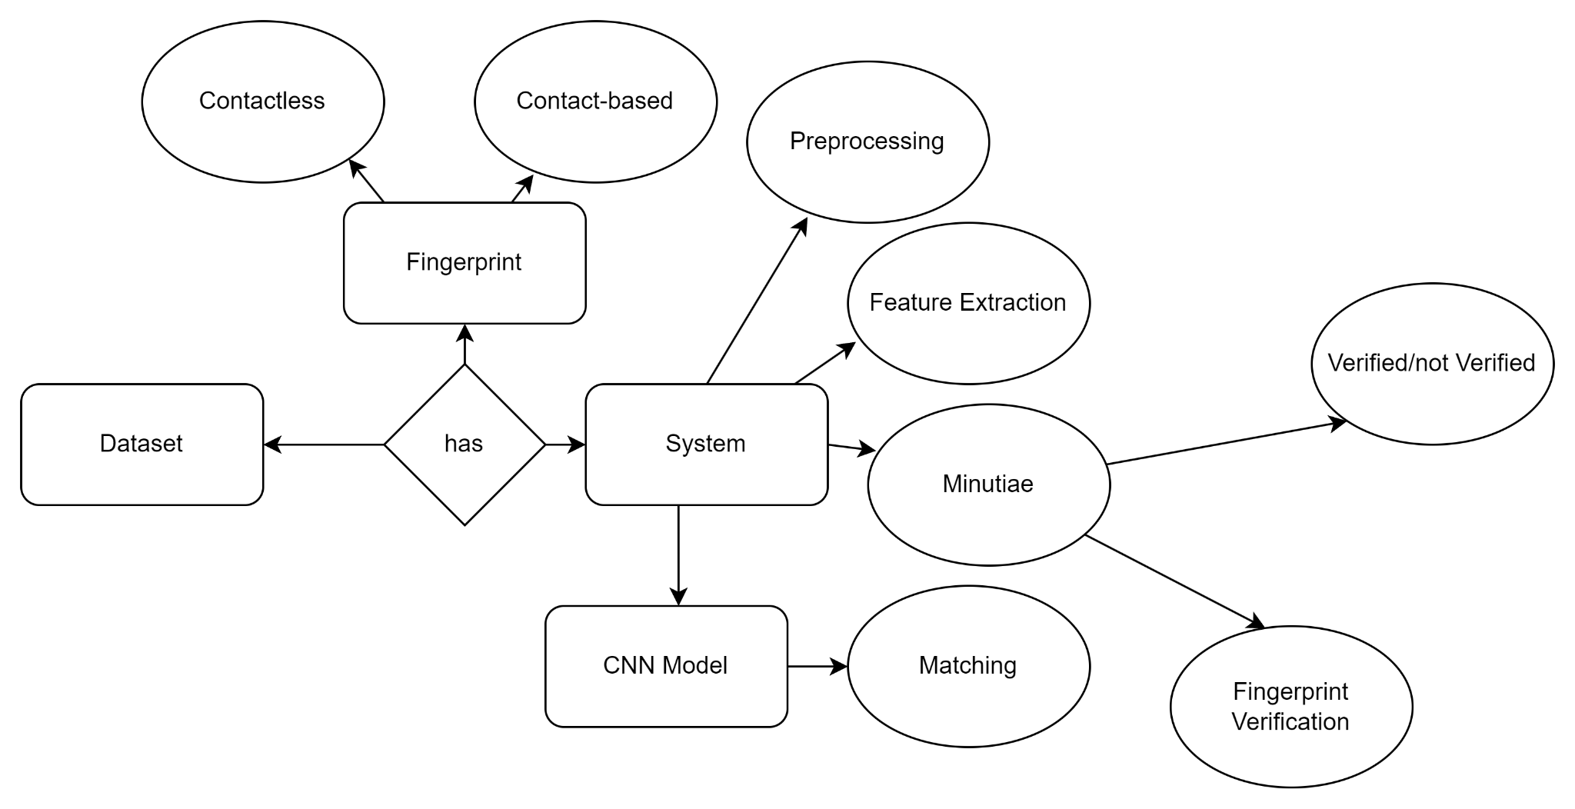

* 1. **ER Diagram**

# DATA DICTIONARY

The below figure depicts the data dictionary of the project. The entity 'pixel' has the attribute image, numpy is the data type. The entity 'dataset' has the attribute class with string as data type. The entity 'pre-process' has the attribute size and integer as data type. The entity 'augmentation' has angle as attribute and float as data type. The entity 'annotation' has annotated file as attribute and json as data type. The final entity 'trained model' has attribute model and h5 as data type.

|  |  |  |  |
| --- | --- | --- | --- |
| **ENTITY** | **ATTRIBUTE** | **DATA TYPE** | **DESCRIPTION** |
| **pixel** | **image** | **numpy.array** | **Input image** |
| **dataset** | **class** | **string** | **dataset label** |
| **preprocess** | **size** | **Int** | **image size** |
| **augmentation** | **angle** | **float** | **rotation range** |
| **annotation** | **annotated file** | **json** | **annotated fingerprint image** |
| **trained model** | **model** | **h5** | **Saving model** |

**4.1 Data Dictionary**

# DATA FLOW DIAGRAM

The below diagram depicts the data flow diagram of the project. The flow starts from fingerprint collection, dataset pre-processing, training data and testing data moving to MINUTIAE algorithm, and cnn model then to feature extracted file, validation & evaluation and finally accuracy will be predicted using web application.

# DFD 0

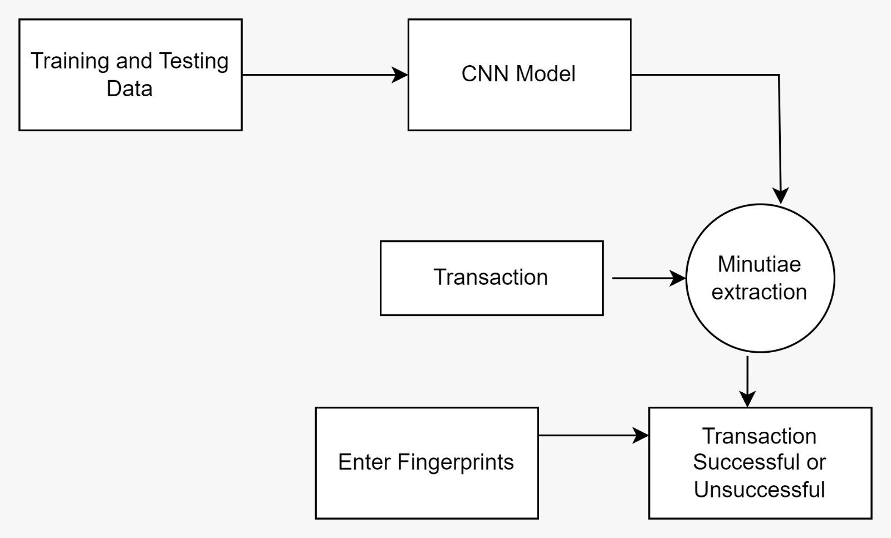

* 1. **DFD Level 0**

# DFD 1

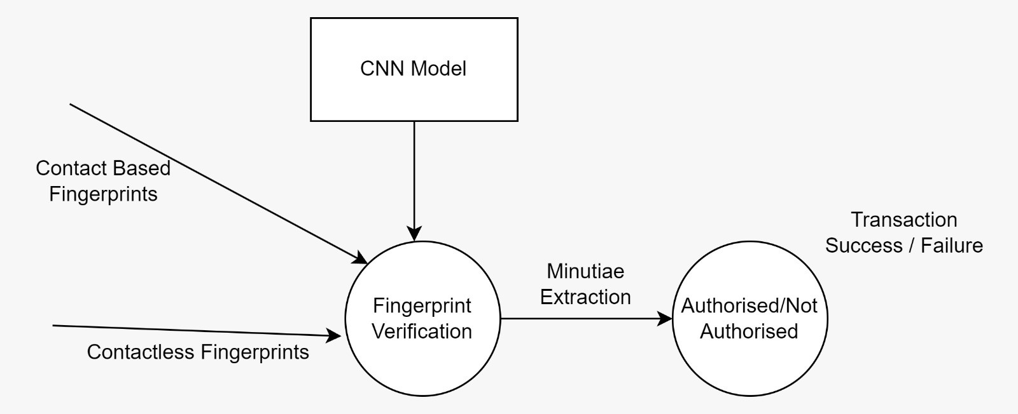

* 1. **DFD Level 1**

# DFD 2

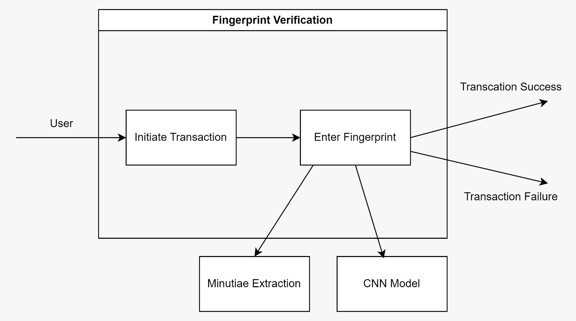

* 1. **DFD Level 2**

# UML DIAGRAMS

* + 1. **USE CASE DIAGRAM**

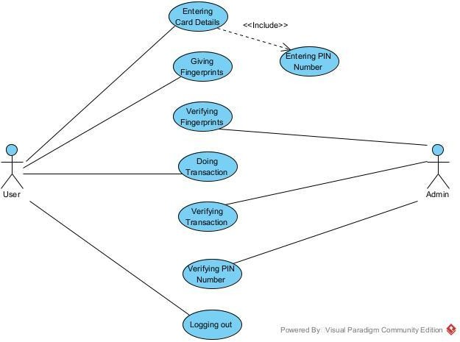The below figure includes 2 actors (user and admin) .The user first enters the card details and then gives the fingerprints for the transaction.Then the admin verifies the details including the PIN number if the PIN and all the given details are correct the transaction will be done.

* 1. **Use Case Diagram**

# CLASS DIAGRAM

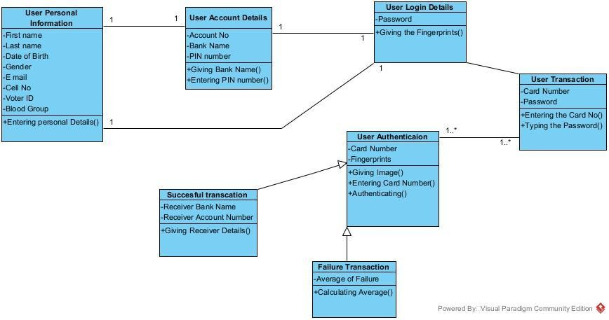The class diagram represents the five main classes.Users Personal information class consists of attributes such as Name,Date of Birth,Gender ,e-mail,Voter ID and it is connected with the Users Account Details which has attributes as Account no,Bank Name,PIN no and it is connected with the class named Users Login Details which has attribute as Password and method as giving the fingerprint which is connected with the class named Users Transaction which has attributes such as card no,Password which is connected with the class named User Authentication which has attributes such as card no,fingerprints which is connected with classes named successful transaction and failure transaction.

* 1. **Class Diagram**

# ACTIVITY DIAGRAM

The below figure represents the activity diagram in which the flow starts by entering all the users details and the users fingerprints for the transaction then the admin will verify all the details whether the given details are authorized,if it is authorized the transaction will be successful.

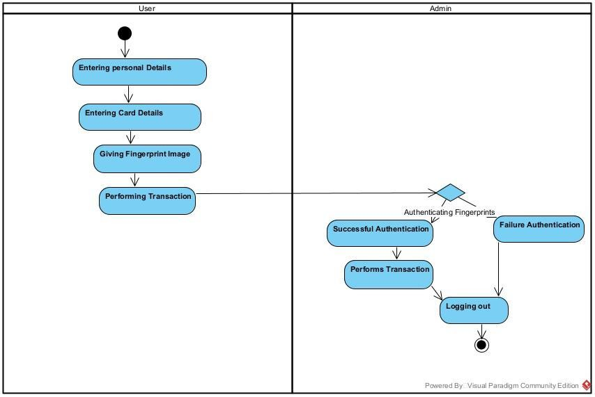

* 1. **Activity Diagram**

# SEQUENCE DIAGRAM

The below figure includes 2 main actors (user, Admin). The user enters his personal details,card details and provides fingerprints for authentication. then the admin stores the user details and verifies the fingerprints, if they are authorized then the transaction will be performed.

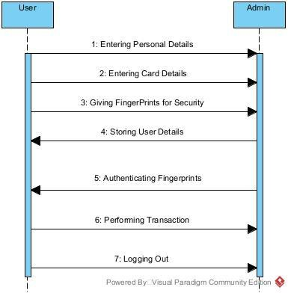

* 1. **Sequence Diagram**

# CHAPTER 5 SYSTEM ARCHITECTURE

# SYSTEM ARCHITECTURE

Architecture diagrams can be important for developing contactless fingerprint recognition systems. Research has been conducted on developing such systems using fingerprint images from mobile cameras and webcams. Other studies have proposed approaches for capturing finger photos from a distance using image sensors and processing them to obtain global and local features. The National Institute of Standards and Technology (NIST) has evaluated commercially available contactless fingerprint scanning technologies and compared their performance to conventional devices that require physical contact between a person's fingers and the scanner. Additionally, a proposed model for correcting deformations on contact-based fingerprints can result in accurate alignment of key minutiae features observed on both contactless and contact-based fingerprints. Therefore, architecture diagrams can be useful for designing and implementing contactless fingerprint recognition systems.

The architecture diagram would typically consist of the following components:

1. Input module: This component is responsible for capturing the fingerprint images, either through a contact or contactless method, and pre-processing the images by applying image enhancement techniques, orientation field estimation, and binarization.
2. Minutiae extraction module: This component is responsible for extracting the minutiae points from the pre-processed fingerprint images. This involves applying ridge thinning algorithms, minutiae detection algorithms, and noise reduction techniques.
3. CNN-based feature extraction module: This component is responsible for extracting features from the minutiae points using a convolutional neural

network (CNN). The CNN architecture can vary depending on the specific approach used, but typically involves convolutional layers followed by max-pooling layers.

1. Matching module: This component is responsible for comparing the feature vectors of two fingerprint images to determine whether they belong to the same person or not. The matching algorithm can use a distance metric such as Euclidean distance or cosine similarity to calculate the distance between the feature vectors.
2. Output module: This component is responsible for displaying the matching results, either in the form of a binary decision (match or no match) or a similarity score.

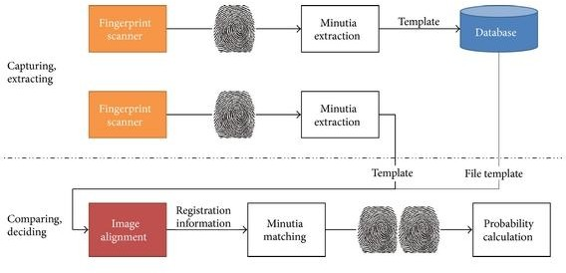

* 1. **Architecture Diagram**

# MODULE DESIGN SPECIFICATION

## Preprocessing

Digital fingerprint recognition is the most widely used biometric technique because of its ease of use and demonstration. The chains of recognition by digital processes are based on image processing techniques making it possible to extract the useful information of each image (fingerprint) in order to be able to identify it and consequently compared it to other fingerprints.Our fingerprints are unique, at least on certain points: these are called minutiae, that is to say, the lines, the bifurcations, the "islets", the points, the ending of the peaks. The design formed by these lines on our fingers never evolves. Depending on the level of security desired, it is estimated that between 10 and 20 points of correspondence are required to certify a fingerprint.

## Grayscale Transformations

The transformation allows us to reduce the space used for recording data included in the image; in fact, the color pixels require 24 bits to be able to represent the different levels of colors, on the other hand in grayscale we only need 8 bits for each pixel since we have only 256 gray levels.

# I=(R+G+B)/3

Where I is the value of the pixel in gray and R, G and B are the values of the color components.

Calculation of the average:



I (i, j) is the value of the pixel (i, j) and M is the value of the average of the image while m and n are the dimensions of the image.

Calculation of variance:

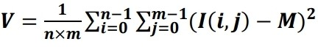

V is the variance of the image.

Calculation of the standardized gray level value of the pixel (i, j):

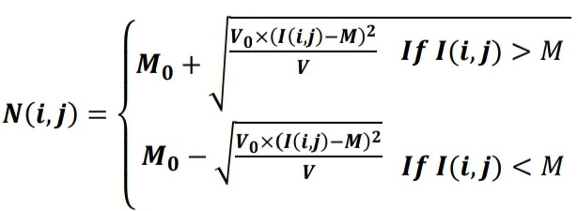

M0 and V0 are the desired values for mean and variance, respectively. We chose M0=100 and V0=100.

## Segmentation

The results of this step is a binary image of the same size as the original image and called "Mask",the block corresponding to the bottom of the image will be filled with 0 in the mask, and the rest will be filled by 1.This is not all to satisfactorily because many blocks containing no useful information persist.To avoid this we decided to eliminate the blocks belonging to the bottom of the image according to their average value. The local average value of each block Ml is calculated and compared to a threshold T:

If M1<T then we consider that the block contains no useful information and it is eliminated.

If M1>T then the block contains part of the fingerprint and is retained.

## Minutiae Feature Extraction

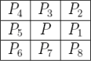The most commonly employed method of minutiae extraction in this category is the Crossing Number (CN) concept. A large number of techniques for minutiae extraction is available which belong to this category.

## 3X3 neighbourhood

This method is favored over other methods for its computational efficiency and inherent simplicity. This method involves the use of the skeleton image where the ridge flow pattern is eight-connected. The minutiae are extracted by scanning the local neighborhood of each ridge pixel in the image using a 3X3 window . The CN value is then computed as follows:

8

CN=0.5∑ | Pi - Pi+1 |

i=1

where P9=P1. It is defined as half the sum of the differences between pairs of adjacent pixels in the eight neighbourhood.Using the properties of the CN, the ridge pixel can then be classified as a ridge ending, bifurcation or non-minutiae point. For example, a ridge pixel with a CN of one corresponds to a ridge ending, and a CN of three corresponds to a bifurcation.

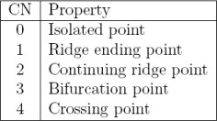

## Properties of Crossing Numbers

* + 1. **Fingerprint Matching**

After extraction for a given pair of contact and contactless fingerprint images , we compute a final match score as a weighted fusion of the individual scores . Finally,the similarity score is calculated. One of the most important and time-consuming tasks of any biometric system evaluation is the data collection. We have created a multi-database, containing disjoint fingerprint databases, each collected with a different sensor/technology. But in this project the sensing device cost is more so that we are going to use the fingerprint image for the distinguishing which is based on the above created card no during performance evaluation, fingerprints belonging to the same database will be matched against each other. The image size and resolution vary depending on the database. Each and every one of our ten fingerprints is unique, different from another and from those of every other person. Even identical twins have unique fingerprints for that reason only we are going to use this for the security Process.After finishing the normal Authentication that is normal username and password authentication the data that is updated during the registration of the card details about the multiple banking accounts is listed out and from that we can select the bank for the further transaction.

## Secure Bank Transaction:

To protect the security of accounts, verify your address before we can send you payment. To do so, we mail a Personal Identification Number (PIN) to your payee profile address. You’ll then need to enter this PIN within your account. That can be used to authenticate the user to the system. Typically, the user is required to provide a non-confidential user identifier and a confidential PIN to gain access to the system. Upon receiving the user ID and PIN, the system looks up the PIN based upon the user ID and compares the looked-up PIN with the received PIN. For the particular banking account. Once the PIN No is verified

then we are ready for the transaction of the amount from the particular banking account the amount transaction is done based on the web service which is used for the detection of amount from the particular account.

# ALGORITHM

* + 1. **FINGERPRINT MINUTIAE EXTRACTION ALGORITHM**

The minutiae based fingerprint recognition algorithm is relatively stable, robust to contrast, image resolutions, and global deformation as compared to pattern based fingerprint recognition method . This approach is the backbone of the current available fingerprint recognition system. Fingerprint identification with minutiae extraction is mainly based on the minutiae points i.e. the direction and location of the ridge endings and bifurcations along the ridge path . It reduces the complex fingerprint recognition problem to a point pattern matching problem. The proposed algorithm includes pre-processing of fingerprint image, feature extraction, post-processing and finally matching decision. Essentially, the matching consists of finding the minimum difference of distance (Dmin) between the saved template and the test minutiae sets having maximum number of minutiae pairings. The test fingerprint matches if (Dmin) is lower than the set threshold.

## Step-by-step description of Algorithm

Step 1: Input the fingerprint image, f (x, y).

Step 2: Conversion of image f (x, y) into grayscale image, fg(x, y). Step 3: Resizing image fg(x, y) to 400 x 400, new image fr(x, y).

Step 4: Enhancing image using histogram equalization and wiener filter to improve quality, degraded by noise like smudgy area, break in ridge, wounds and sweat. The histogram of a digital image with gray levels in the range [0, L-1] is a discrete function.

h(r k) = n k

r k- k th Gray level,

n k- Number of pixels in the image.

Step 5: Finding the core point of the fingerprint image fr(x, y).

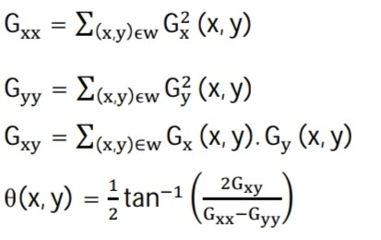The image is divided into a non-overlapping blocks of size ‘w’ 10 x 10. The horizontal gradient ‘Gx(x, y)’ and vertical gradient ‘Gy(x, y)’ at each pixel (x, y) is computed using Sobel mask of size 3 x 3 and the ridge orientation ‘θ(x, y)’ of each pixel is given by ,

Now, ridge orientation is smoothed using Gaussian low pass filter. As singular point has the maximum curvature. so, it is located by measuring strength of the peak. Further, applying thinning followed by Morphological closing and opening to locate singular point in original fingerprint image.

Step 6: Extraction of a circle of radius ‘R’ with core point as centre of the fingerprint image fr(x, y) to get new image fc(x, y) in the region of interest (ROI) because area near singular point contains correct and efficient information about fingerprint.

Step 7: Conversion of image fc(x, y) into binary image fb(x, y) by thresholding. Pixel value above the threshold is assigned to 1 and below to 0. Here threshold = 160.

Step 8: Applying thinning operation on the image fb(x, y) to get thinned image ft(x, y). Thin operation reduces width of ridges to one pixel wide.

Step 9: Extracting minutiae points (terminations and bifurcations) of ft(x, y) using Cross-number (CN) concept. It is computationally efficient and inherently simple.

The minutiae points are extracted by scanning the local neighborhood of each pixel in the ridge thinned image, using a 3 x 3 window.

The CN value is defined as half the sum of the differences between pairs of adjacent pixels, Pi and Pi+1 in the eight neighborhood and computed by,

The ridge pixel is classified as a ridge ending and bifurcation having cross-number 1 and 3 respectively. Data matrix is generated to get the position, orientation and type of minutiae.

Step 10: Post-processing to remove spurious minutiae, observed due to undesired spikes, breaks, and holes. Morphological operation namely clean, spur and H-break is employed on thinned image ft(x, y) to get image fm (x, y) .

Step 11: Finding true minutiae points in ROI of fm(x, y) to get final image ffinal(x,y) after removing spurious minutiae in the cases, if

1. distance between a termination and a bifurcation is smaller than D
2. distance between two bifurcations is smaller than D
3. distance between two terminations is smaller than D

‘D’ is the average distance between minutiae points. Here D = 6.

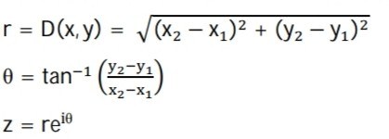Step 12: Representation of linear distance and angle of each minutia in ROI with respect to core point in polar form. The linear distance and angle between core point (x1,y1) and minutia (x2,y2) is given by,

Step 13: Taking Fourier transform and saving the Fourier coefficients in ‘.dat’ file. Step 14: Creation of template of fingerprint database.

Step 15: Calculation of the parameter Euclidean distance (Dmin) between saved template and the test fingerprint template.

Step 16: Minimum (Dmin) is compared with the set threshold to get result whether ‘match’ or ‘not match’.

## Convolutional Neural Networks (CNN) Introduction

A system of interconnected artificial neurons that have learnable weights and biases forms a Convolutional Neural Network. These neurons exchange messages with each other. The connections have numeric weights tuned during the training process so that a properly trained network will respond correctly when presented with an image or pattern to recognize.

The network consists of multiple layers of feature-detecting neurons. Each layer has many neurons that respond to different combinations of inputs from the previous layers. As shown in Figure 5.12, the layers are built up so that the first layer detects a set of primitive patterns in the input, the second layer detects patterns of patterns, and the third layer detects patterns of those patterns.

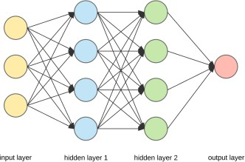

## An Artificial Neural Network

**Layers of CNN**

For classification problems, complex architectures are built by stacking multiple and different layers in a CNN. The four layers are convolution, pooling/subsampling layers,non-linear (ReLU) layers, and fully connected layers. The below figure shows the various layers of CNN. A portion of the input image is fed to the convolution layer. The output of this layer is then fed to the pooling layer. This is repeated, followed by a fully connected layer that performs classification.

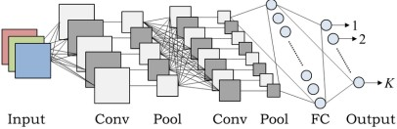

## Architecture of CNN

**Convolutional Layer**

The convolution operation extracts various features of the input. The first convolution layer is responsible for extracting low-level features such as edges, lines, and corners. Higher-level layers extract Higher-level features. Figure 5.14 depicts the convolution process used in CNNs.

The input is of size N x N x D and is convolved with H kernels, each of size k x k x D separately. Convolution of input with one kernel produces one

output feature, and with H kernels independently has H features. Starting from the top-left corner of the input, each kernel is moved from left to right, one element at a time. Once the top-right corner is reached, the kernel is moved one element in a downward direction, and again the kernel is moved from left to right, one element at a time. This process is repeated until the kernel reaches the bottom-right corner.

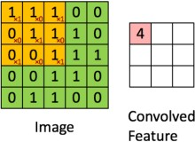

## Representation of Convolutional Process

For example, if N = 5 and k = 5, there are five different positions from left to right and five different positions from top to bottom that the kernel can take. Corresponding to these positions, each feature in the output will contain 28x28 (i.e., (N-k+1) x (N-k+1)) elements. For each kernel position in a sliding window process, k x k x D elements of input and k x k x D elements of the kernel are element-by-element multiplied and accumulated. So to create one element of one output feature, k x k x D multiply-accumulate operations are required.

## Pooling Layer

The pooling (subsampling) layer helps to reduce the resolution of the features. The features are robust against noise and distortion. The two ways to perform

pooling operations are as follows: max pooling and average pooling. In both cases, the input is divided into non-overlapping sub-regions. Figure 6 elaborates further on the pooling process.

The input image is of size 4x4 input image is divided into four non-overlapping matrices, each of size 2x2 shown in green, yellow, red, and blue squares. The maximum value of the four values in the 2x2 matrix (21 from the green matrix, 12 from the yellow matrix, 18 from the red matrix, and 10 from the blue matrix) is taken as the output in the max-pooling operation.

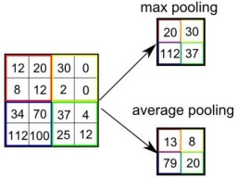

## Representation of Max Pooling and Average Pooling

But in the case of average pooling, the average of the four values (15 from the green matrix, nine from the yellow matrix, 12 from the red matrix, and seven from the blue matrix) is taken as the output. If averaging is a fraction, it has to be rounded to the nearest integer.

## Activation Functions

1. **Rectified Linear Unit (ReLU)**

The ReLU layer implements the function: y=max(x,0). Now the input and output sizes of this layer are the same.

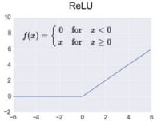

## ReLU Transfer Function

This operation increases the nonlinear properties of the decision function, including the overall network. This does not affect the respective fields of the convolution layer. Compared to the other nonlinear functions used in CNN’s (e.g., Sigmoid, hyperbolic tangent, and absolute hyperbolic tangent), the significant advantage of a ReLU is that the network trains many times faster.

The functionality of ReLU is illustrated in Figure 8. The transfer function plotted above the arrow. All the positive values(15, 20, 35, 18, 25, 100, 20, 25, 101, 75, 18, 23) are retained as such and the negative

values (-10, -110, -15, -10) are converted to zero.

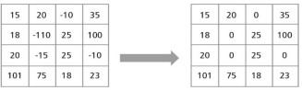

## Representation of ReLU Functionality

1. **Softmax Function**

The Softmax Activation Function (also known as SoftArgMax or Normalized Exponential Function) is an activation function that takes

vectors of real numbers as inputs and normalizes them into a probability distribution proportional to the exponential of input numbers.

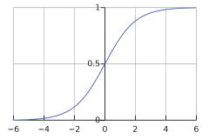Before applying this function, consider some input data that could be negative or greater than 1. Also, they might not sum up to 1. After applying Softmax, each element will be in the range of 0 to 1, and the elements will add up to 1.

## Softmax Transfer Function



The softmax function makes sure that the sum of all our output probabilities is equal to one. This is the main reason to include softmax activation in a multi-class classification problem.

CNNs have been proven to be highly acceptable for various computer vision tasks, especially image classification . In the proposed approach, raw fingerprint image captured by the image sensor is directly fed into customized siamese CNN. The main idea for using CNN is that a fingerprint image has lots of global features that can easily be captured by CNN. The major factor that needs to be taken care of is the size of the image. More importantly, the image size should not shrink while

going deeper into the network because a fingerprint image has regular patterns, which would be ineffective if the image size shrinks. To keep the size of the image intact after each set of convolution layer filters performed. During the construction of the siamese architecture, the convolution layers and the dense layers were taken into account such that a minimum number of parameters are utilized in the architecture. This is done to reduce the latency of the system when deployed on the hardware. The number of the convolution layers were limited to 3 each having 4, 8 and 8 filters and batch normalization layers respectively. At the end of the convolution layers, an average pooling is employed so that the least number of parameters are required while passing through the dense layers. In order to match and generate a matching score between a given pair of fingerprint templates, a siamese network is employed. It makes use of two identical CNNs with shared weights. While training the neural network, it minimizes the distance between two similar templates and maximizes the distance between two dissimilar templates with the help of distance aware contrastive loss function . The contrastive loss function is defined as :

where

2 2

L = (1 − Y )1/2 (Dw) + (Y ) 1/2 (max(0, m − Dw))

Dw : Euclidean Distance between outputs vectors or embeddings of size 16 × 1 of siamese networks

m : margin value (dissimilar pairs beyond the margin didn’t contribute to loss). The embedding vectors of size 16×1 from the siamese network is used to compute Euclidean distance between any two templates. This Euclidean distance acts as the dissimilarity score (because CNN is trained to maximize this distance between two dissimilar templates and vice versa). Finally, the similarity score (Sd) is calculated by taking the inverse of the dissimilarity score.

# CHAPTER 6 SYSTEM IMPLEMENTATION

# CLIENT SIDE CODING

## Createcard.jsp

<%@page import="java.text.SimpleDateFormat"%>

<%@page import="java.util.Calendar"%>

<%@page import="java.text.DateFormat"%>

<%@page contentType="text/html" pageEncoding="UTF-8"%>

<!DOCTYPE html>

<!DOCTYPE html PUBLIC "-//W3C//DTD XHTML 1.0 Transitional//EN" "<http://www.w3.org/TR/xhtml1/DTD/xhtml1-transitional.dtd>">

<html xmlns="<http://www.w3.org/1999/xhtml>">

<head>

<script language="javascript" type="text/javascript" src="datetimepicker.js"></script>

<link rel="stylesheet" href="<http://code.jquery.com/ui/1.10.2/themes/smoothness/jquery-ui.css>" />

<script src="<http://code.jquery.com/jquery-1.9.1.js>"></script>

<script src="<http://code.jquery.com/ui/1.10.2/jquery-ui.js>"></script>

<script>

$(function() {

$( "#datepicker" ).datepicker({ changeMonth : true, changeYear : true,

yearRange: '-100y:c+nn'

});

});

</script>

<script type="text/javascript">

// Popup window code function db(ele)

{

var k=ele; alert(k)

<%

%>

alert("hi");

<%//} %>

}

var co=0;

function newPopup(url) {

var c= document.getElementById("voterno").value; var u=url+"?vid="+c;

var ur = /^[0-9]{7}$/.test(c); if(!ur){

alert("Invalid Voter id");

}else{ co=1;

popupWindow = window.open( u,'popUpWindow','height=500,width=500,left=300,top=100,resizable=yes,scrollba rs=yes,toolbar=yes,menubar=no,location=no,directories=no,status=yes');

}}

</script>

<meta http-equiv="Content-Type" content="text/html; charset=utf-8" />

<title>STCARD - Create Card</title><link rel="stylesheet" type="text/css" href="style.css" />

<%String Servlet_Msg = (String) session.getAttribute("msg"); String color = (String) session.getAttribute("color");%>

<%!

String k2="";

%>

<script type="text/javascript"> var xmlHttp

function showBank(str){

if (typeof XMLHttpRequest != "undefined"){ xmlHttp= new XMLHttpRequest();

}

else if (window.ActiveXObject){

xmlHttp= new ActiveXObject("Microsoft.XMLHTTP");

}

if (xmlHttp==null){

alert("Browser does not support XMLHTTP Request") return;

}

var vn = "";

vn= document.form1.voterno.value; var url="CSPNAME.jsp";

url +="?count=" +vn;

// alert(vn);

xmlHttp.onreadystatechange = stateChange; xmlHttp.open("GET", url, true); xmlHttp.send(null);

}function stateChange(){

if (xmlHttp.readyState==4 || xmlHttp.readyState=="complete"){ document.getElementById("us").innerHTML=xmlHttp.responseText

}

}

</script>

<script>

function formValidation()

{var fn = document.form1.fname;

var dob = document.form1.datepicker; var ph = document.form1.cellno;

var sex = document.form1.sex; var vn = document.form1.voterno;

var email = document.form1.email; var pwd =document.form1.passwd;

var repwd = document.form1.retypepassword; var filen = document.getElementById('file'); if(fn_validation(fn,3))

{

if(Date_validation(dob))

{

if(Ph_validation(ph,10))

{

if(Sex_validation(sex))

{

if(Vn_validation(vn,7))

{

if(Email_validation(email))

{if(Link_validation(co))

{if(Pwd_validation(pwd,5))

{if(RePwd_validation(pwd,repwd))

{if(File_validation(filen))

{return true; } }}}}}}}}} return false;

}

function fn_validation(uid,mx)

{

var uid_len = uid.value.length; if (uid_len == 0 )

{

alert("First Name should not be empty "); uid.focus();

return false;

}

else if( uid_len < mx)

{

alert("First Name length Should be >= "+mx+" "); uid.focus();

return false;

}

return true;

}

function Date_validation(uid)

{

var uid_len = uid.value.length; if (uid_len == 0)

{alert('Date of Birth Should Not be Empty'); uid.focus();

return false;

}return true;

}

function Ph_validation(uzip,mx)

{

var uid_len = uzip.value.length; var numbers = /^[0-9]+$/;

if(uzip.value.match(numbers) && uid_len==mx)

{

return true;

}

else if (uid_len == 0)

{

alert('Cell No Should Not be Empty'); uzip.focus();

return false;

}else if ((uzip.value.match(numbers)) && (uid_len<mx) ||(uid_len>mx) )

{

alert("Cell No Length Should be "+mx+""); uzip.focus();

return false;

}else if(uzip.value.match(numbers)!=0)

{alert('Cell No must have numeric characters only'); uzip.focus();

return false;

}

}

function Sex_validation(uid)

{

if(uid.value == "Sex")

{

alert("Please Choose the Gender"); uid.focus();

return false;

}

return true;

}

function Vn_validation(uzip,mx)

{

var uid_len = uzip.value.length; var numbers = /^[0-9]+$/;

if(uzip.value.match(numbers) && uid_len==mx)

{return true;

}

else if (uid_len == 0)

{

alert('VoterId No Should Not be Empty'); uzip.focus();

return false;

}else if ((uzip.value.match(numbers)) && (uid_len<mx ||uid_len>mx ))

{

alert("VoterId No Length Should be "+mx+""); uzip.focus();

return false;

}

else if(uzip.value.match(numbers)!=0 && uzip.value=="Already Exist")

{alert('VoterId No Already Exist'); uzip.focus();

return false;

}

else if(uzip.value.match(numbers)!=0)

{alert('VoterId No must have numeric characters only'); uzip.focus();

return false;}}

function Email_validation(uid)

{var uid_len = uid.value.length;

var reg = /^([A-Za-z0-9_\-\.])+\@([A-Za-z0-9_\-\.])+\.([A-Za-z]{2,4})$/; if (uid_len == 0)

{alert('Email Address Should Not be Empty'); uid.focus();

return false;}

else if (reg.test(uid.value) == false)

{alert('Invalid Email Address.Email Address Should be Like This Example:Alice@PLC.com');

return false;} return true;

}

function Ps_validation(uid)

{

var uid_len = uid.value.length; if (uid_len == 0 )

{

alert("Permanent Street should not be empty "); uid.focus();

return false;} return true;}

function Pa_validation(uid)

{var uid_len = uid.value.length; if (uid_len == 0 )

{alert("Permanent Area should not be empty "); uid.focus();

return false;

}

return true;

}

function Pc_validation(uid)

{

var uid_len = uid.value.length; if (uid_len == 0 )

{

alert("Permanent Place should not be empty "); uid.focus();

return false;

}return true;

}

function Pp_validation(uzip,mx)

{var uid_len = uzip.value.length; var numbers = /^[0-9]+$/;

if(uzip.value.match(numbers) && uid_len==mx)

{return true;}

else if (uid_len == 0)

{alert('Pin Number Should Not be Empty'); uzip.focus();

return false;

}else if ((uzip.value.match(numbers)) && (uid_len<mx || uid_len>mx))

{alert("Pin Number Length Should be "+mx+""); uzip.focus();

return false;

}

else if(uzip.value.match(numbers)!=0){

alert('Pin Number must have numeric characters only'); uzip.focus();

return false;

}}

function Link_validation(c)

{if(c==1)

{return true;} else

{alert("Please Click the Account Details"); return false;}

return true; }

function Pwd_validation(uid,mx)

{var uid_len = uid.value.length; if (uid_len == 0 )

{alert("Password should not be empty "); uid.focus();

return false;

}

else if (uid_len > 0 && uid_len < mx)

{alert("Password length should be >= "+mx); uid.focus();

return false;

}

return true;

}

function RePwd_validation(uid,rep)

{var uid_len = rep.value.length; if (uid_len == 0 )

{

alert("Please Re-Type Your Password"); rep.focus();

return false;

}

else if(uid_len > 0 && uid.value!=rep.value)

{alert("Password Not match"); rep.focus();

return false; } return true;}

function File_validation(uid)

{var uid_len = uid.value.length; var file=uid.files[0];

var uid_len = uid.value.length; if (uid_len == 0 )

{alert("Fingerprint image Should not be empty"); uid.focus();

return false;}

else if (uid_len > 0 && !/(\.bmp|\.gif|\.jpg|\.jpeg)$/i.test(uid.value))

{alert("Please Make Sure You Choosen only Image File"); return false;

}

else if(uid_len > 0 && uid_len > 0 && /(\.bmp|\.gif|\.jpg|\.jpeg)$/i.test(file) && file.size >= 1048576){

alert("Fingerprint image Size Should be less than 1MB only"); uid.focus();

return false;} return true;}

</script>

<meta http-equiv="Content-Type" content="text/html; charset=utf-8" />

<title>Simple Grid Theme, Free CSS Template</title>

<meta name="keywords" content="simple, grid, theme, free templates, web design, one page layout, slategray, steelblue, templatemo, CSS, HTML" />

<meta name="description" content="Simple Grid is a one-page website template provided by templatemo.com" />

<link href="css/templatemo_style.css" rel="stylesheet" type="text/css" />

<script type="text/javascript">

$(document).ready(function () {

$.localScroll();

});

</script>

</head>

<body>

<div id="templatemo_wrapper">

<div id="templatemo_header">

<div id="site_title">Authentication of Fingerprints for Bank Transaction</a></div><br>

</div>

<div id="templatmeo_menu">

<ul>

<li><a href="Mainform.jsp" class="home"><span></span></a></li>

<li><a href="Createcard.jsp" class="about"><span></span></a></li>

<li><a href="Transaction.jsp" class="portfolio"><span></span></a></li>

<li><a href="" class="services"><span></span></a></li>

<li><a href="Mainform.jsp" class="contact"><span></span></a></li>

</ul>

</div>

<div id="templatemo_main">

<%

if(Servlet_Msg!=null){

%>

<center><blink> <font size="3" color="<%=color%>"><label><%=Servlet_Msg%></label></font></blink></cent er><br><br><%

session.removeAttribute("msg"); session.removeAttribute("color");}%><% DateFormat dateFormat = new SimpleDateFormat("dd-MM-yyyy");

Calendar cal = Calendar.getInstance(); String d1=dateFormat.format(cal.getTime()); System.out.println(d1); session.removeAttribute("vn");

/*}*/%>

<div id="container" class="clearfix">

<div id="mainCol" class="clearfix">

<center> <form name="form1" id="form1" method="post" action="CreatecardCheck" enctype="multipart/form-data" onsubmit="return formValidation();"><TABLE style=" margin-right: "cellSpacing=0 cellPadding=0 width=590 bgColor=#6699cc border=0>

<TBODY>

<TR>

<TD vAlign=top height=321 width="592">

<TABLE cellSpacing=0 cellPadding=0 width="592" border=1 height="381">

<TBODY>

<TD vAlign=top width=612 style="background-color:#1b1d1f" height="381">&nbsp;&nbsp;&nbsp;&nbsp;&nbsp;&nbsp;&nbsp;&nbsp;&nbsp;& nbsp;&nbsp;&nbsp;&nbsp;&nbsp;&nbsp;&nbsp;&nbsp;&nbsp;&nbsp;&nbsp;&nb sp;&nbsp;&nbsp;&nbsp;&nbsp;&nbsp;&nbsp;&nbsp;&nbsp;&nbsp;&nbsp;&nbsp

;&nbsp;&nbsp;&nbsp;&nbsp;&nbsp;&nbsp;&nbsp;&nbsp;&nbsp;&nbsp;&nbsp; &nbsp;&nbsp;&nbsp;&nbsp;&nbsp;&nbsp;&nbsp;&nbsp;&nbsp;

<b>&nbsp;&nbsp;</b>&nbsp;&nbsp;&nbsp;&nbsp;&nbsp;&nbsp;&nbsp;&nbsp; &nbsp;&nbsp;&nbsp;&nbsp;&nbsp;&nbsp;&nbsp;&nbsp;<p align="center">

<font face="Arial" color="#6699CC" size="4"><b>Account Holder Registration Form&nbsp;</b></font><table border="0" cellpadding="0" cellspacing="0" style="border-collapse: collapse" bordercolor="#111111" width="610" id="AutoNumber6" height="470">

<td width="39">

<br>

<tr>

<td width="39" height="58">&nbsp;</td>

<td width="567" height="58"><b>Personal Information</b>

<table border="0" cellpadding="0" cellspacing="0" style="border-collapse: collapse" bordercolor="#111111" width="561" id="AutoNumber7" height="51">

<tr>

<td width="97" height="26">

First Name<sup><font size="3" color="red">*</font></sup></td>

<td width="161" height="26"><FONT color=#004080><INPUT name=fname size="16" tabIndex=1></FONT></td>

<td width="116" height="25">&nbsp;&nbsp;&nbsp;&nbsp;&nbsp;&nbsp;&nbsp;&nbsp;

Last Name</td>

<td width="179" height="25"><FONT color=#004080>

<INPUT name=lname size="16" tabIndex=2></FONT></td>

</tr>

<tr>

<td width="97" height="13">Date Of Birth<sup><font size="3" color="red">*</font></sup></td>

<td width="161" height="13">

<input name="datepicker" id="datepicker" class="validate-email required input_field" />

</td>

<td width="116" height="24" rowspan="2">&nbsp;&nbsp;&nbsp;&nbsp;&nbsp;&nbsp;&nbsp;&nbsp;&nbsp;Ce ll

No<sup><font size="3" color="red">*</font></sup> </td>

<td width="179" height="24" rowspan="2"><FONT color=#004080>

<INPUT name=cellno size="16" tabIndex=6></FONT></td>

</tr><tr> </tr><tr><td width="97" height="12">Gender<sup><font size="3" color="red">*</font></sup></td>

<td width="161" height="12">

<FONT color=#ae0000>

<SELECT name=sex size=1 tabIndex=7> <OPTION value="Sex">Sex<OPTION value=Male>Male<OPTION value=Female>Female

</OPTION></SELECT></FONT></td><td width="116"

height="25">&nbsp;&nbsp;&nbsp;&nbsp;&nbsp;&nbsp;&nbsp;&nbsp;&nbsp;Vot erId No <sup><font size="3" color="red">*</font></sup></td><td width="179" height="25" id="us"><FONT color=#004080>

<INPUT name=voterno id="voterno" tabIndex=8 size="16">&nbsp;</FONT></td>

</tr>

<tr>

<td width="97" height="25">E-mail<sup><font size="3" color="red">*</font></sup></td>

<td width="161" height="25" ><FONT color=#004080>

<INPUT name=email tabIndex=9 size="16" ></FONT></td>

<td width="116" height="24">&nbsp;&nbsp;&nbsp;&nbsp;&nbsp;&nbsp;&nbsp;&nbsp;&nbsp;Blo od Group </td>

<td width="179" height="24"><FONT color=#004080>

<INPUT name=bg tabIndex=10 size="16">&nbsp;</FONT></td>

</tr>

<tr>

<td width="555" colspan="4">

<br>

</tr>

</table>

</td> </tr><tr>

<td width="39" height="50"> &nbsp;</td><td width="567" height="50">

<p><b>Account Details <sup><font size="3" color="red">*</font></sup></b>

</p><table border="0" width="100%" cellpadding="0" cellspacing="0" height="40">

<tr><td>Add Account Details</td>

<td><label name="link"><a href="JavaScript:newPopup('AddAccount.jsp')" size=1 tabIndex=18 >Click Here</a></label></font></td>

</tr> </table>

</td> </tr> <tr>

<td width="39" height="228"> &nbsp;</td>

<td width="567" height="228">

<TABLE border=0 cellPadding=0 cellSpacing=0 style="LEFT: 527px; TOP: 1709px" width="515" height="40">

<br><b>Login Details</b>

<TR><TD width="284" height="28"></TD>

<TD width="367" height="28"></TD></TR>

<TR><TD width="284" height="23">Enter Your Password <sup><font size="3" color="red">*</font></sup></TD>

<TD width="367" height="23"><INPUT name=passwd tabIndex=39 type=password size="20"></TD></TR>

<TR><TD width="284" height="26">Re-Type Your Password <sup><font size="3" color="red">*</font></sup></TD>

<TD width="367" height="26"><INPUT name="retypepassword" tabIndex=40 type=password size="20"></TD></TR>

<TR><TD width="284" height="28">Fingerprint Image <sup><font size="3" color="red">*</font></sup></TD>

<TD width="367" height="28">

<input type="file" name="file" id="file" value="Browse"tabIndex=42 size="20"/></TD></TR>

</TABLE>

<p>

<FONT

color=#004080>&nbsp;&nbsp;&nbsp;&nbsp;&nbsp;&nbsp;&nbsp;&nbsp;&nbsp; &nbsp;&nbsp;&nbsp;&nbsp;&nbsp;&nbsp;&nbsp;&nbsp;&nbsp;&nbsp;&nbsp;& nbsp;&nbsp;&nbsp;&nbsp;&nbsp;&nbsp;&nbsp;&nbsp;&nbsp;&nbsp;&nbsp;&nb sp;&nbsp;&nbsp;&nbsp;&nbsp;&nbsp;&nbsp;&nbsp;&nbsp;&nbsp;&nbsp;&nbsp

;&nbsp;&nbsp;&nbsp;&nbsp;&nbsp;&nbsp;&nbsp;&nbsp;&nbsp;&nbsp;&nbsp; &nbsp;&nbsp;&nbsp;&nbsp;&nbsp;&nbsp;

&nbsp;&nbsp;&nbsp;&nbsp;&nbsp;&nbsp; <INPUT name=submit tabIndex=43 type=Submit value=Create>&nbsp;&nbsp;&nbsp;&nbsp;&nbsp;&nbsp;&nbsp;&nbsp;&nbsp;& nbsp;&nbsp;

<INPUT name=reset style="LEFT: 386px; TOP: 1893px" tabIndex=44 type=reset value=Reset>&nbsp;&nbsp;&nbsp;&nbsp;&nbsp;&nbsp;&nbsp;&nbsp;&nbsp;&n bsp;&nbsp;&nbsp;&nbsp;&nbsp;&nbsp;&nbsp;&nbsp;&nbsp;&nbsp;

<a href="#top" style="text-decoration: none">Top</a></FONT>

</td></tr>

</table><font color="#6699CC">&nbsp;&nbsp;&nbsp;&nbsp;&nbsp;&nbsp;&nbsp;&nbsp;&nb sp;&nbsp;&nbsp;&nbsp;&nbsp;&nbsp;&nbsp;&nbsp;&nbsp;&nbsp;&nbsp;&nbsp

;&nbsp;

<font color="black">Note:</font> Your Card Number Provides after Creation Only&nbsp;<br>

&nbsp;&nbsp;&nbsp;&nbsp;&nbsp;&nbsp;&nbsp;&nbsp;&nbsp;&nbsp;&nbsp;& nbsp;&nbsp;&nbsp;&nbsp;&nbsp;&nbsp;&nbsp;&nbsp;&nbsp;&nbsp;

<sup><font size="3" color="red">*</font> - Mandatory</sup></font></TD>

</TBODY></TABLE></TD></TR></TBODY></TABLE> </form></center>

</div> <!-- END of --></div></div></div>

<div id="templatemo_footer">

Copyright © 2048 Your Company Name<br /> Designed by <a href="" rel="nofollow" target="_parent">Free CSS Templates</a>

</div>

</div>

<script type='text/javascript' src='js/logging.js'></script>

</body>

</html>

# SERVER SIDE CODING

## DB.java

package Connection; import java.sql.*; public class DB { public Connection con; public Statement st; public ResultSet rs; public DB() {

try { Class.forName("com.mysql.jdbc.Driver");

con=DriverManager.getConnection("jdbc:mysql://localhost:3306/smartcard","root"

,"admin"); System.out.println("Connected");

} catch (Exception e) {

System.out.println("Error Inside DataBase class :\nError in DataBaseConstructor\n" + e);

}}public int Insert(String Query) { int i = 0;

try {con = new DB().con; st = con.createStatement();

i = st.executeUpdate(Query); st.close();

con.close();} catch (Exception ex) { System.out.println("Error Insert DataBase class " + ex);

}return i;}

public ResultSet Select(String Query) { try {if (st != null && con != null) { st.close();

con.close();}

con = new DB().con;

st = con.createStatement(); rs = st.executeQuery(Query);

} catch (Exception e) { e.printStackTrace();} return rs;}} **CreatecardCheck.java** import Connection.DB;

import java.io.DataInputStream; import java.io.File;

import java.io.FileInputStream; import java.io.FileOutputStream;

import java.io.IOException; import java.io.InputStream; import java.io.PrintWriter; import java.sql.*;

import java.text.SimpleDateFormat; import java.util.Iterator;

import java.util.List;

import java.util.logging.Level; import java.util.logging.Logger;

import javax.servlet.ServletException; import javax.servlet.annotation.WebServlet; import javax.servlet.http.HttpServlet;

import javax.servlet.http.HttpServletRequest; import javax.servlet.http.HttpServletResponse; import javax.servlet.http.HttpSession;

import org.apache.commons.fileupload.FileItem;

import org.apache.commons.fileupload.FileUploadException; import org.apache.commons.fileupload.disk.DiskFileItemFactory; import org.apache.commons.fileupload.servlet.ServletFileUpload;

@WebServlet(name = "CreatecardCheck", urlPatterns = {"/CreatecardCheck"}) public class CreatecardCheck extends HttpServlet {protected void processRequest(HttpServletRequest request, HttpServletResponse response) throws ServletException, IOException, SQLException { response.setContentType("text/html;charset=UTF-8");

PrintWriter out = response.getWriter(); HttpSession session=request.getSession(true); try {DB Db=new DB();

String plan = request.getParameter("plan");

System.out.println("Plan Type " + plan);

String saveFile="",fn="",ln="",mname="",dob="",celno=""; String sex="",voterno="",email="",bg="",pstreet="",cstreet="", parea="",carea="",pcity="" ,ccity="";

String ppinno="",cpinno="",pass="",repass=""; int fileidnum=0,downloadcount=0;

String contentType = request.getContentType(); DiskFileItemFactory factory = new DiskFileItemFactory(); factory.setSizeThreshold(4012);

ServletFileUpload upload = new ServletFileUpload(factory); List items = null;

try {items = upload.parseRequest(request);

} catch (FileUploadException e) { e.printStackTrace();}

byte[] data = null; String fileName = null;

Iterator iter = items.iterator();

while (iter.hasNext()) {FileItem item = (FileItem) iter.next(); if (item.isFormField()) {

String name = item.getFieldName(); String value = item.getString();

if (name.equalsIgnoreCase("fname")) { fn = value;

System.out.println("fn" + fn);

} else if (name.equalsIgnoreCase("lname")) { ln = value;

System.out.println("ln " + ln);

} else if (name.equalsIgnoreCase("datepicker")) {dob = value;

System.out.println("dob " + dob);

} else if (name.equalsIgnoreCase("cellno")) { celno = value;

System.out.println("sims " + celno);

} else if (name.equalsIgnoreCase("sex")) { sex = value;

System.out.println("camera " + sex);

} else if (name.equalsIgnoreCase("voterno")) { voterno = value;

System.out.println("bluetooth " + voterno);

} else if (name.equalsIgnoreCase("email")) { email = value;

System.out.println("memory " + email);

} else if (name.equalsIgnoreCase("bg")) { bg = value;

System.out.println("radio " + bg);

} else if (name.equalsIgnoreCase("p_streetname")) { pstreet = value;

System.out.println("internet " + pstreet);}

else if (name.equalsIgnoreCase("c_streetname")) { cstreet = value;

System.out.println("internet " + cstreet);} else if (name.equalsIgnoreCase("p_area")) { parea = value;

System.out.println("internet " + parea);} else if (name.equalsIgnoreCase("c_area")) { carea = value;

System.out.println("internet " + carea);}

else if (name.equalsIgnoreCase("p_city")) { pcity = value;

System.out.println("internet " + pcity);} else if (name.equalsIgnoreCase("c_city")) { ccity = value;

System.out.println("internet " + ccity);}

else if (name.equalsIgnoreCase("p_pinno")) { ppinno = value;

System.out.println("internet " + ppinno);} else if (name.equalsIgnoreCase("c_pinno")) { cpinno = value;

System.out.println("internet " + cpinno);} else if (name.equalsIgnoreCase("passwd")) { pass = value;

System.out.println("internet " + pass);}

else if (name.equalsIgnoreCase("retypepassword")) { repass = value;

System.out.println("internet " + repass);} else {System.out.println("ERROR");

}} else {data = item.get(); fileName = item.getName();}} boolean st=false;

ResultSet rs=Db.Select("select * from createcard where voterno="+voterno); if(rs.next())

{session.setAttribute("msg", "This VoterId Number is already Exist!!!"); session.setAttribute("color", "red"); response.sendRedirect("Createcard.jsp");}

else{st=true;}

rs.close(); if(st==true)

{rs=Db.Select("select * from accountdetails where pn="+voterno); if(rs.next())

{saveFile = fileName;

String path = request.getSession().getServletContext().getRealPath("/"); File ff = new File(path+saveFile);

FileOutputStream fileOut = new FileOutputStream(ff); fileOut.write(data, 0, data.length);

fileOut.flush(); fileOut.close();

System.out.println(path+saveFile); System.out.println("Thrid"); Connection con = null; PreparedStatement psmnt = null; FileInputStream fis;

InputStream sImage; try {

java.util.Date now = new java.util.Date();

String DATE_FORMAT = "yyyy-MM-dd hh:mm:ss"; SimpleDateFormat sdf = new SimpleDateFormat(DATE_FORMAT); String strDateNew = sdf.format(now); System.out.println(strDateNew);

try {File f = new File(path+saveFile); long length = f.length(); System.out.println("length " + length);

String query = "insert into createcard values('" + fn + "','" + ln + "','" + dob + "','"

+ celno + "','" + sex + "','"+voterno+"','" + email + "','" + bg + "','" + pstreet + "','" +

cstreet + "','" + parea + "','"+carea+"','" + pcity + "','" + ccity + "','" + ppinno + "','"

+ cpinno + "','" + pass + "','"+repass+"')"; con=Db.con;

int s=Db.Insert(query);

String queryString = "insert into fbauthentication(voterno,email,cardno,pass, FileName, Content, Fdate,otp)values (? ,?,? ,? ,?,?,?,?)";

psmnt = con.prepareStatement(queryString); fis = new FileInputStream(f); psmnt.setString(1, voterno); psmnt.setString(2, email); psmnt.setString(3, "no");

psmnt.setString(4, "no"); psmnt.setString(5, saveFile);

psmnt.setBinaryStream(6, (InputStream) fis, (int) (f.length())); psmnt.setString(7, strDateNew);

psmnt.setString(8, "no");

int i = psmnt.executeUpdate(); if (s > 0 && i>0) { session.removeAttribute("vn");

session.setAttribute("msg", "Hi, "+fn+" "); session.setAttribute("color", "green"); session.setAttribute("pass", pass); session.setAttribute("vn", voterno); response.sendRedirect("Uniquecode.jsp");

} else {session.setAttribute("msg", "Card Number Creation Failed!!!"); session.setAttribute("color", "red"); response.sendRedirect("Createcard.jsp");}

} catch (Exception ex) {ex.printStackTrace();

}} catch (Exception e) { e.printStackTrace();}} else

{session.setAttribute("msg", "Card Number Creation Failed.Please Give your Account Details or Check ur VoterId Number!!!"); session.setAttribute("color", "red");

response.sendRedirect("Createcard.jsp"); } rs.close();} }

finally {out.close();

}}

protected void doGet(HttpServletRequest request, HttpServletResponse response) throws ServletException, IOException {

try {processRequest(request, response);

} catch (SQLException ex) { Logger.getLogger(CreatecardCheck.class.getName()).log(Level.SEVERE, null, ex);}}

protected void doPost(HttpServletRequest request, HttpServletResponse response) throws ServletException, IOException {

try {processRequest(request, response);

} catch (SQLException ex) { Logger.getLogger(CreatecardCheck.class.getName()).log(Level.SEVERE, null, ex);}}

public String getServletInfo() { return "Short description";}}

# CHAPTER 7 SYSTEM TESTING

* 1. **TEST CASES AND REPORTS**

|  |  |  |  |  |  |  |  |
| --- | --- | --- | --- | --- | --- | --- | --- |
| TEST CASE ID | TEST CASE/ACTION TO BE  PERFORMED | | EXPECTED RESULT | | ACTUAL RESULT | | FAIL/PASS |
| 1 | Check fingerprints  available | if are | fingerprints are uploaded | | fingerprints Uploaded | are | Pass |
| 2 | Preprocessing the  fingerprints | | Process  fingerprints | the | Process  fingerprints | the | Pass |
| 3 | Pin verification | | Verifies unique  number | the pin | Verifies unique  number | the pin | Pass |
| 4 | Minutiae algorithm | | Predict probability ridges  furrow | the of and | Predict probability ridges  furrow | the of and | Pass |
| 5 | Authentication fingerprints | of | Verifies the given fingerprints are  valid | | Verifies given fingerprints  valid | the  are | Pass |

|  |  |  |  |  |
| --- | --- | --- | --- | --- |
| 6 | Secure bank transaction | Verification of all details with fingerprints, pins and  account details | Verification of all details with fingerprints, pins and account  details | Pass |

**7.1 Test Cases and Reports**

# PERFORMANCE ANALYSIS

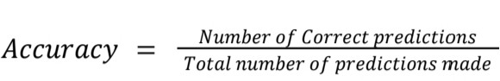Evaluating your machine learning algorithm is an essential part of any project. Classification Accuracy is what we usually mean when we use the term accuracy. It is the ratio of the number of correct predictions to the total number of input samples.

It works well only if there are an equal number of samples belonging to each class. To prevent the false sense of achieving high accuracy, we use more metrics to study the data prediction more.

## Confusion Matrix

A Confusion matrix is an N x N matrix used for evaluating the performance of a classification model, where N is the number of target classes.The matrix compares the actual target values with those predicted by the machine learning model. This gives us a holistic view of how well our classification model performs and what kinds of errors it is making. For a binary classification problem, we would have a 2 x 2 matrix as shown below

with four values:

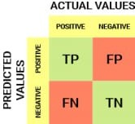

## 7.1 Confusion Matrix

These are the four important terms:

* True Positives: The cases in which we predicted YES and actual output was also YES.
* True Negatives: The cases in which we predicted NO and the actual output was NO.
* False Positives: The cases in which we predicted YES and the actual output was NO.
* False Negatives: The cases in which we predicted NO and actual output was YES.

Further, this gives rise to three crucial classification score indices interesting for multi-class classification models - Precision, Recall, and F1-Score.

## Precision

The number of correct positive results divided by the number of positive results predicted by the classifier is Precision.

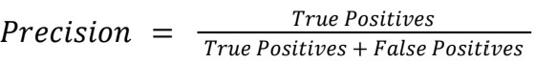

## Recall

Recall tells us how many of the actual positive cases we could predict correctly with our model. The number of correct positive results is divided by the number of all relevant samples (all samples that should have been identified as positive) is known as Recall.

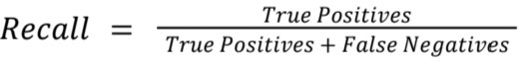

## F1-Score

F1 Score is used to measure a test’s accuracy. It is the Harmonic Mean between precision and recall. The range for the F1 Score is [0, 1]. It tells you how precise your classifier is (how many instances it classifies correctly), as well as how robust it is (it does not miss a significant number of instances). High precision but lower recall gives you an extremely accurate, but it then misses many instances that are difficult to classify. The greater the F1 Score, the better is the performance of our model. Mathematically, it can be expressed as :

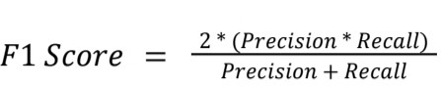

**CHAPTER 8**

**CONCLUSION AND FUTURE ENHANCEMENTS**

# CONCLUSION

This paper has described the development of a deformation correction model for efficiently and accurately matching contactless and contact-based conventional fingerprint images. We proposed a robust thin-plate spline model that was incorporated for the correction of deformations to address contact based and contactless sensor interoperability problems. The proposed model (section III) is generalized, does not rely on the quality of extracted minutiae and has shown to achieve significant improvement in the alignment of contact-based and contactless fingerprints. A method to estimate contact-based fingerprint impression type and intensity is also introduced.

Matching finger-photo and fingerprint images is challenging due to the elastic and perspective distortions between the two modalities. However, the model outlined in this paper can overcome these issues and estimates the fingerprint version of a given finger photo sample. This paper also incorporated a deep model to identify features capable of direct matching of finger-photos against fingerprints. In fact, it was demonstrated that the embedded domain was able to match samples from the two modalities. We also proposed a non-intrusive network that could be used in tandem with any existing commercial fingerprint matching software using a verifier to make sure the generator was creating realistic synthetic fingerprints from the finger-photos. Just the verifier alone was not enough to create usable synthetic contact-based fingerprints because the minutiae of these fake images were blurry and ill defined. Hence, a MinutiaeNet verifier was added to pix2pix to have the pix2pix model focus more on the minutiae points when synthesizing images.

# FUTURE ENHANCEMENTS

As part of future work, we would like to implement our developed model on a microcontroller and GPU for faster computation and embed it on the Printed Circuit Board (PCB) along with image sensor and image capturing environment. This way, our developed model would have the potential of the standalone embedded device.This thesis can be expanded on, there is still room to grow in the fingerprint reconstruction field. While the best results of finger-photo to fingerprint conversion is promising when it comes to matching minutiae points, visually the reconstructed fingerprints look fuzzy around the edges . If this tool is to be used more universally used it needs to be better at creating synthetic images visually as well as in the embedded domain to allow for any existing fingerprint matching system to use the reconstructed fingerprint. The dataset should also be screened to account for any biases in the types of fingerprints. There are three distinct types of fingerprints including the whorl, loop, and arch. Our dataset could have an uneven distribution of these fingerprint types since they do not occur evenly among the population, the existing network could have a bias towards a specific one of these fingerprint types and needs to be identified moving forward so the bias can be removed or accounted for.

# APPENDICES

# SAMPLE SCREENS

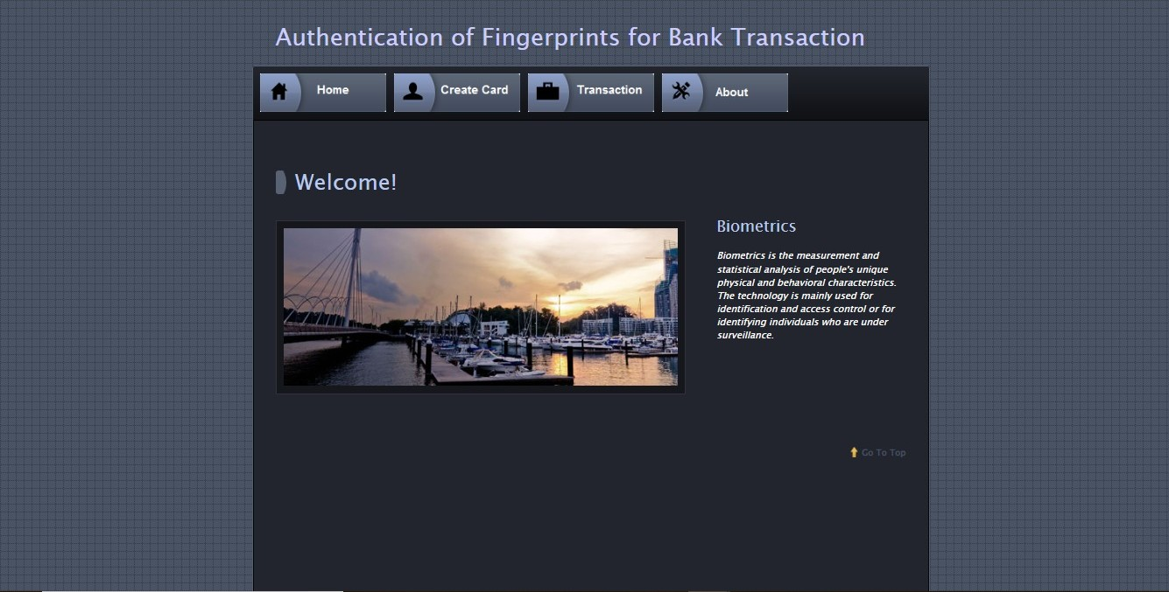

* 1. **Home Page**

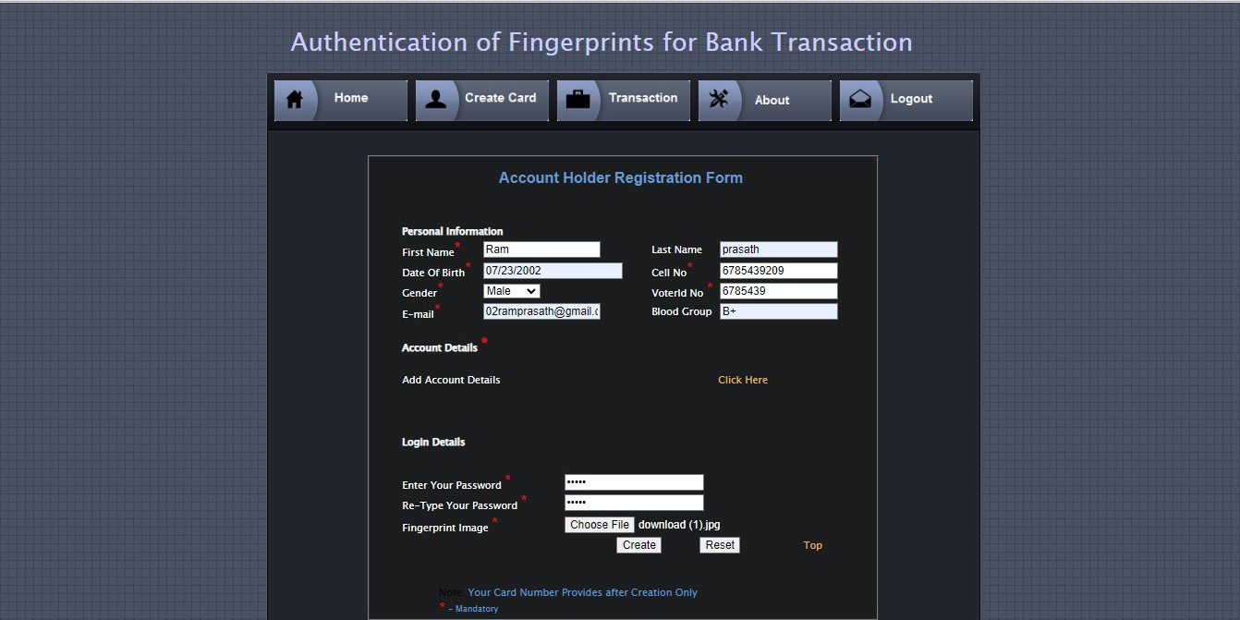

* 1. **Create Card Page**

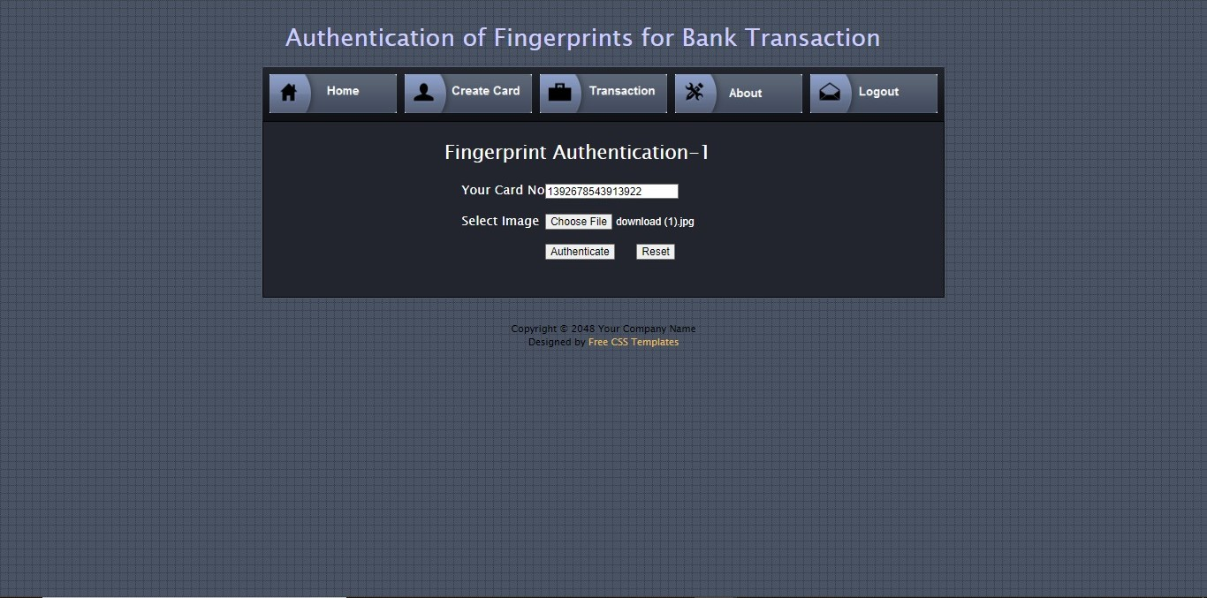

**A.3 Fingerprint Authentication Page**

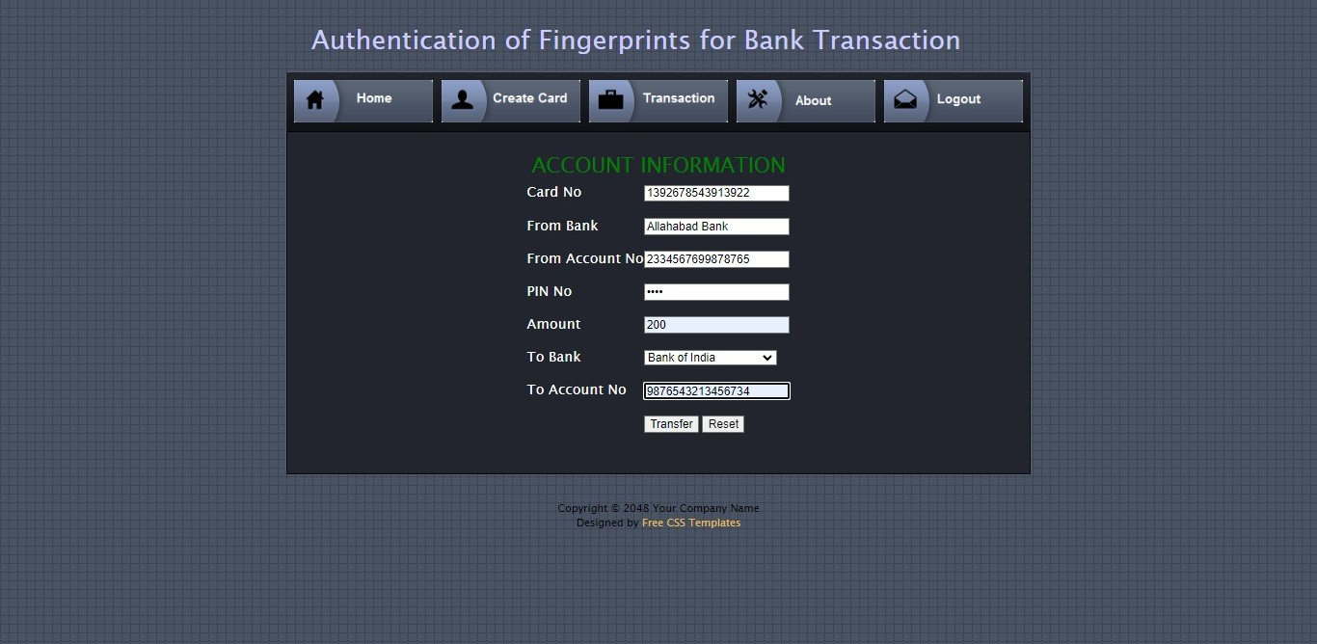

* 1. **Transaction Page**

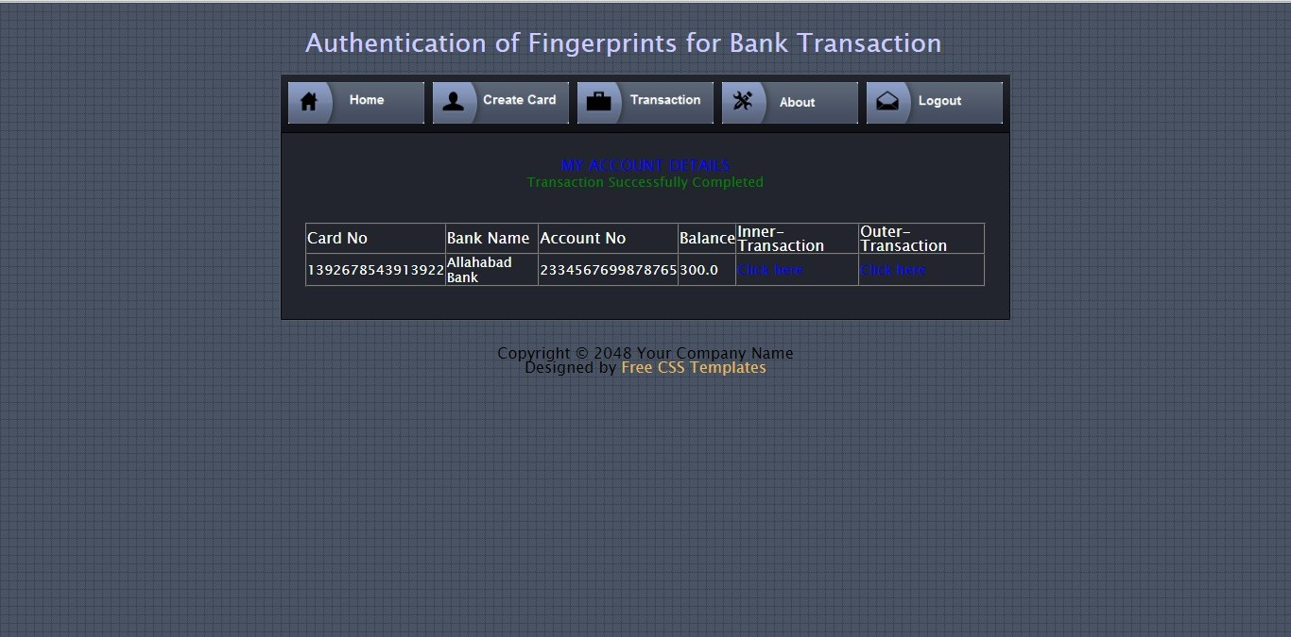

* 1. **Transaction Successful**

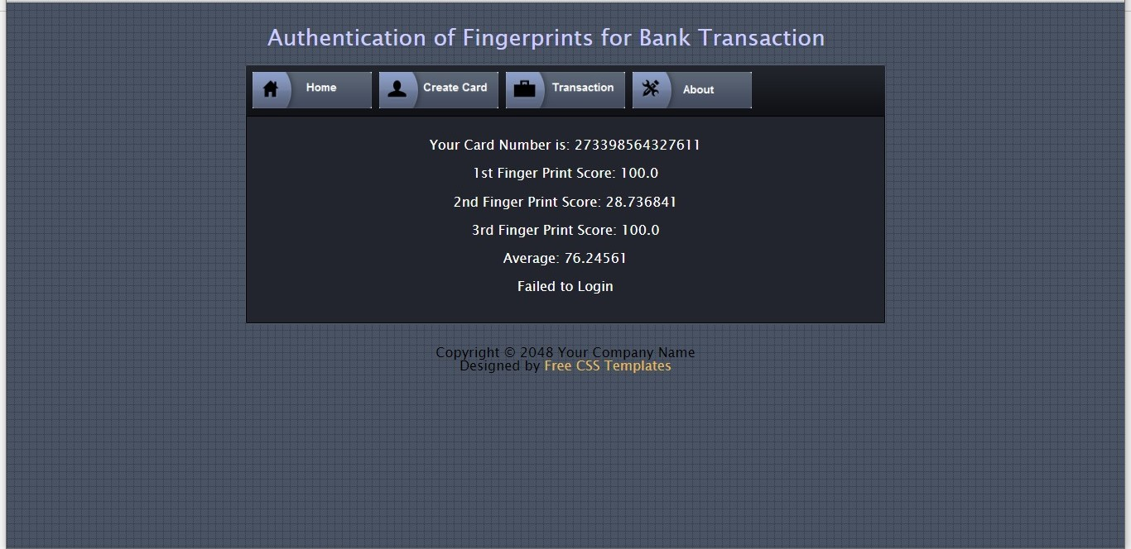

* 1. **Transaction Failure**

# REFERENCES

1. Chenhao Lin, Ajay Kumar,“A CNN-based Framework for Comparison of Contactless to Contact-based Fingerprints”,in IEEE TRANSACTIONS ON INFORMATION FORENSICS AND SECURITY, VOL.14, NO.3, pp.662-676, 2022,DOI: 10.1109/TIFS.2022.2854765.
2. Yelin Shi , Zhao Zhang, Shuxin Liu, and Manhua Liu, “Towards More Accurate Matching of Contactless Fingerprints With a Deep Geometric Graph Convolutional Network” , in IEEE Transactions on Biometrics, Behavior, and Identity Science, VOL. 5, NO. 1, pp.29-38 JANUARY 2023, DOI:10.1109/TBIOM.2022.3219842.
3. Steven A. Grosz , Joshua J. Engelsma , Eryun Liu , ,and Anil K. Jain ,“C2CL: Contact to Contactless Fingerprint Matching”,in IEEE TRANSACTIONS ON INFORMATION FORENSICS AND SECURITY,VOL. 17, pp.196-210 ,2022, DOI:10.1109/TIFS.2021.3134867.
4. Yang Yu, Haixia Wang , Yilong Zhang , Ronghua Liang , and Peng Chen , “Methods and Applications of Fingertip Subcutaneous Biometrics Based on Optical Coherence Tomography”, in IEEE Transactions on Biometrics, Behavior, and Identity Science , VOL.5, NO.1, pp.126-150, JANUARY 2023, DOI:10.1109/TBIOM.2022.3196916.
5. A M Mahmud Chowdhury and Masudul Haider Imtiaz , “Contactless Fingerprint Recognition Using Deep Learning—A Systematic Review”,in MDPI,VOL.2,NO.3, pp.714–730,2022,DOI: 10.3390/jcp2030036 .
6. Bernhard Prommegger; Georg Wimmer; Andreas Uhl, “Cross Sensor Finger Vein Recognition”,in IEEE International Conference of the Biometrics Special Interest Group,2022,DOI: 10.1109/BIOSIG55365.2022.9896962.
7. Shengjie Chen, Zhenhua Guo, Xiu Li, Dongliang Yang, “Query 2 Set: Single-to-Multiple Partial Fingerprint Recognition Based on Attention Mechanism”,in IEEE Transactions on Information Forensics and Security

,VOL.17,pp.12431253,2022,DOI:10.1109/TIFS.2022.3159151.

1. Md Mahedi Hasan, Nasser Nasrabadi,Jeremy Dawson, “Deep Coupled GAN-Based Score-Level Fusion for Multi-Finger Contact to Contactless Fingerprint Matching”,in IEEE International Conference of the Biometrics Special Interest Group (BIOSIG),2022, DOI: 10.1109/BIOSIG55365.2022.9897056.
2. Nesreen Alsharman,Adeeb Saaidah,Omar Almomani,Ibrahim Jawarneh,and Laila Al-Qais, “Pattern Mathematical Model for Fingerprint Security Using

Bifurcation Minutiae Extraction and Neural Network Feature Selection”,in Hindawi Security and CommunicationNetworks,VOL.2022,Article ID 4375232,DOI:https://doi.org/10.1155/2022/4375232

1. B. Uma Maheswari, M. P. Rajakumar and J. Ramya, “Dynamic differential annealing-based anti-spoofing model for fingerprint detection using CNN”

,Neural Computing and Applications ,VOL.34, pp .8617-8633 ,2022, DOI:https://doi.org/10.1007/s00521-021-06758-1.

1. Yongjie Duan, Ke He, Jianjiang Feng, Jiwen Lu, Jie Zhou, “Estimating 3D Finger Pose via 2D-3D Fingerprint Matching”, published in 27th International Conference on Intelligent User Interfaces ,March 2022 ,pp.459–469, DOI:https://doi.org/10.1145/3490099.3511123.
2. Fahman Saeed,Muhammad Hussain and Hatim A. Aboalsamh, “Automatic Fingerprint Classification Using Deep Learning Technology (DeepFKTNet)”,in MDPI,VOL.10,NO.8,2022,DOI:https://doi.org/10.3390/math10081285.
3. Yunpeng Song ,Zhongmin Cai , “Integrating Handcrafted Features with Deep Representations for Smartphone Authentication”, in Proceedings of the ACM on Interactive, Mobile, Wearable and Ubiquitous Technologies, VOL.6, NO.1, pp.1-27,2022, DOI:https://doi.org/10.1145/3517332.
4. Xu Liang, Dandan Fan, Jinyang Yang, Wei Jia, Guangming Lu, David Zhang, “PKLNet: Keypoint Localization Neural Network for Touchless Palmprint Recognition Based on Edge-Aware Regression”,in IEEE Journal of Selected Topics in Signal Processing (Early Access) , pp.1-15 , 2023, DOI:10.1109/JSTSP.2023.3241540.
5. Young Won Lee and Kang Ryoung Park , “Recent Iris and Ocular Recognition Methods in High- and Low-Resolution Images: A Survey”,in MDPI,VOL.10,NO.12,2022,DOI:https://doi.org/10.3390/math10122063.